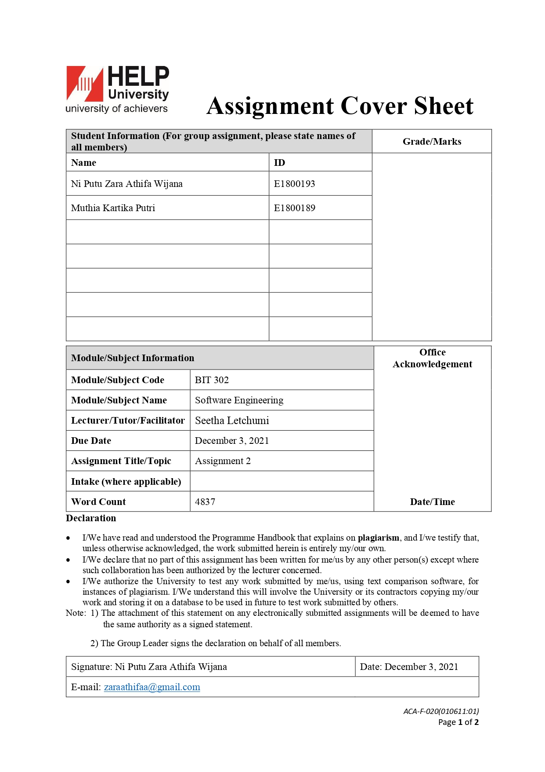

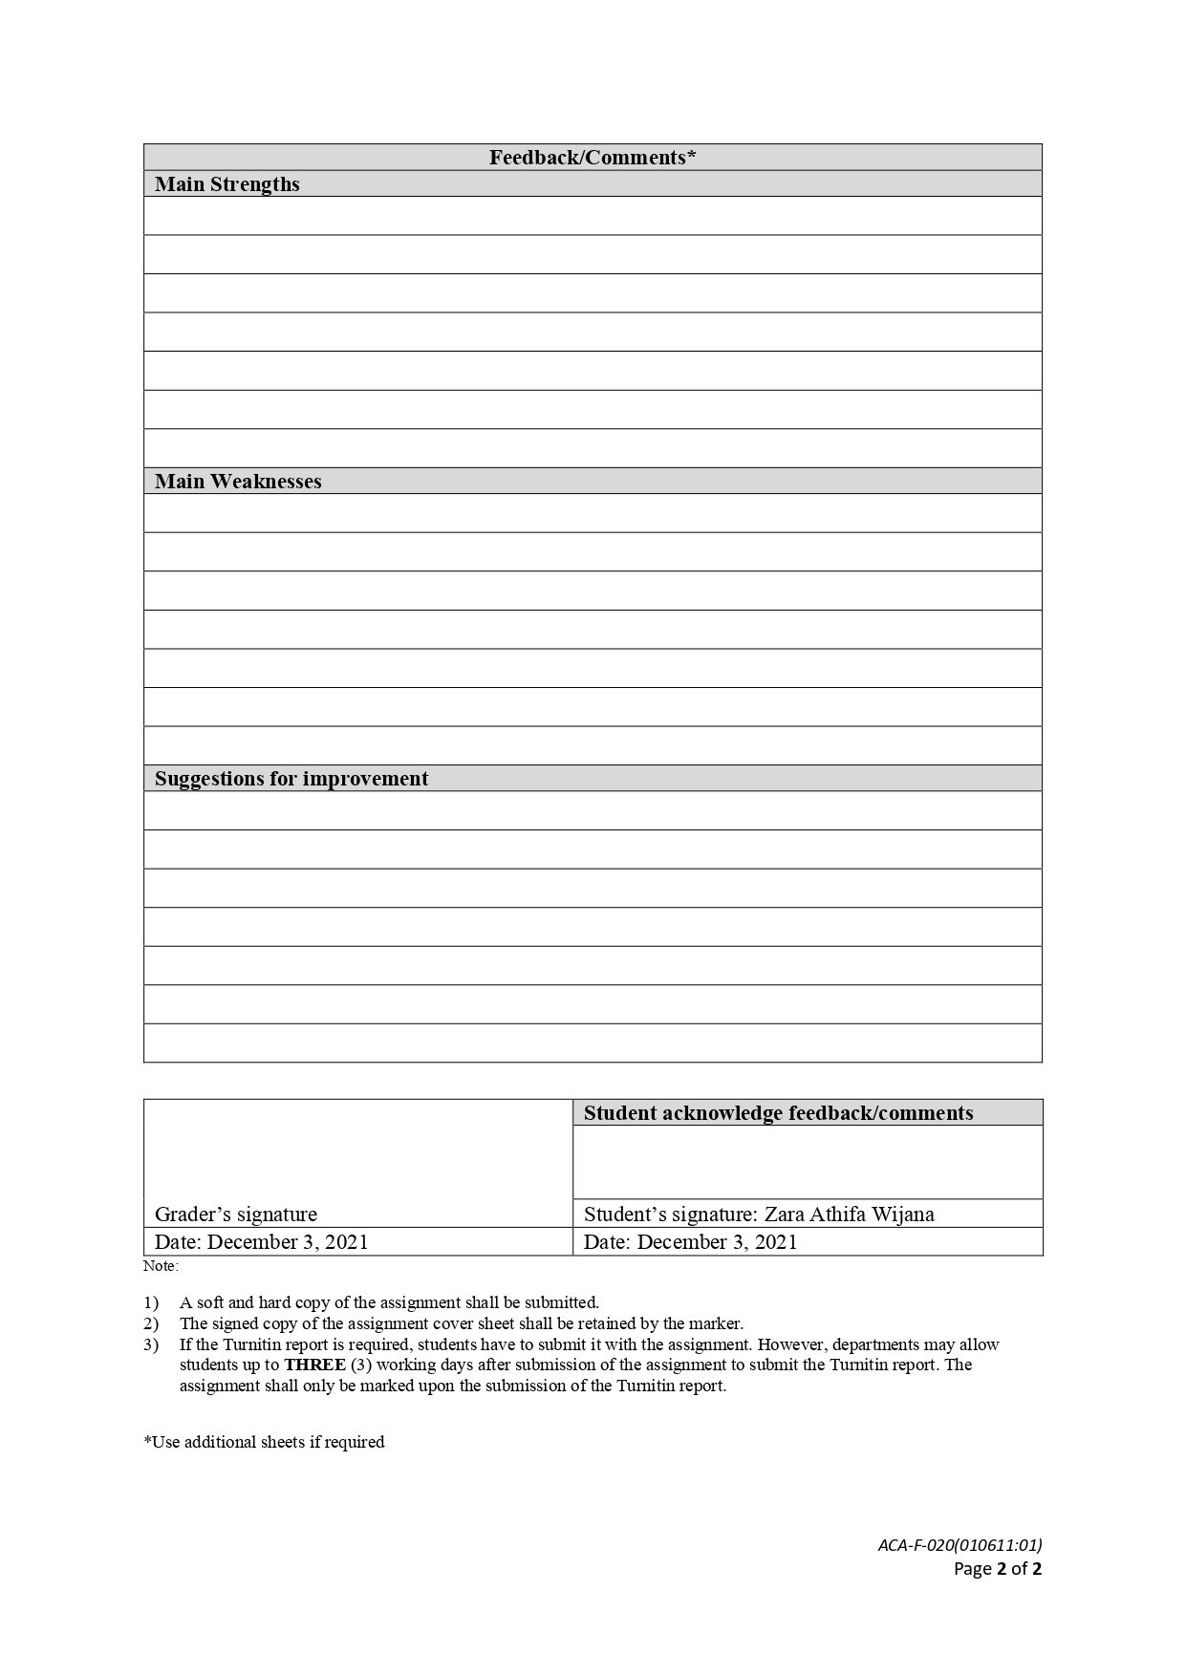

Assignment 1

BIT302

MY Private Vaccine: A Web Based Private Covid-19 Vaccination System

Design Specification Document



Ni Putu Zara Athifa Wijana (E1800193)

[zaraathifaa@gmail.com](mailto:zaraathifaa@gmail.com)

as Team Leader

Muthia Kartika Putri (E1800189)

[muthiakartika2 @gmail.com](mailto:awidyaandika@gmail.com)

as Team Member

2021

Table of Contents

I. Introduction to Design Documentation 1

A. Introduction 1

B. Use Case Diagram 2

C. Requirements Specification 3

II. Design Specification 5

A. Class Diagram 5

B. ERD 6

C. Site Map 6

D. Generic User Experience/Wireframe 7

E. System design of the system 11

F. Database Design 14

III. Iteration 1 16

A. Identification 16

B. Test Objectives 17

C. Test Plan 17

D. Test Results 18

1. Unit Testing 18

2. Integration Testing 22

3. System Testing 31

E. Test Analysis Report 50

F. Gantt Chart Update 50

G. Git Hub 52

IV. References 53

# Introduction to Design Documentation

## Introduction

The MY Private Vaccine website development project aims to act as a middleman between patients who want to be vaccinated, private hospitals that provide vaccinations, and a national vaccination database. We are also required to create design specification documents in addition to project proposals and requirements specification document. The purpose of this design specification document is to outline the critical points that must be met.

This document will contain:

* Introduction with a use case diagram and an explanation of whether or not we have made any updates to the requirements specification that we have previously made.
* Design specification that cover Architectural design specifications, which include Design Class Diagrams, ERDs, Site Maps, Generic User Experience/Wireframes, and System design from the MY Private Vaccine system, which will explain the requirements that have been determined and will include updates on System Sequence Diagrams and Contracts to be developed for Iteration 1, as well as Database design.
* Details about iteration 1 development and testing, including test objectives, results, how to test, integration tests with reports, and Gantt chart updates that we completed during the second phase of this project's development to ensure and guarantee that the project's results will meet various pre-determined requirements

## Use Case Diagram

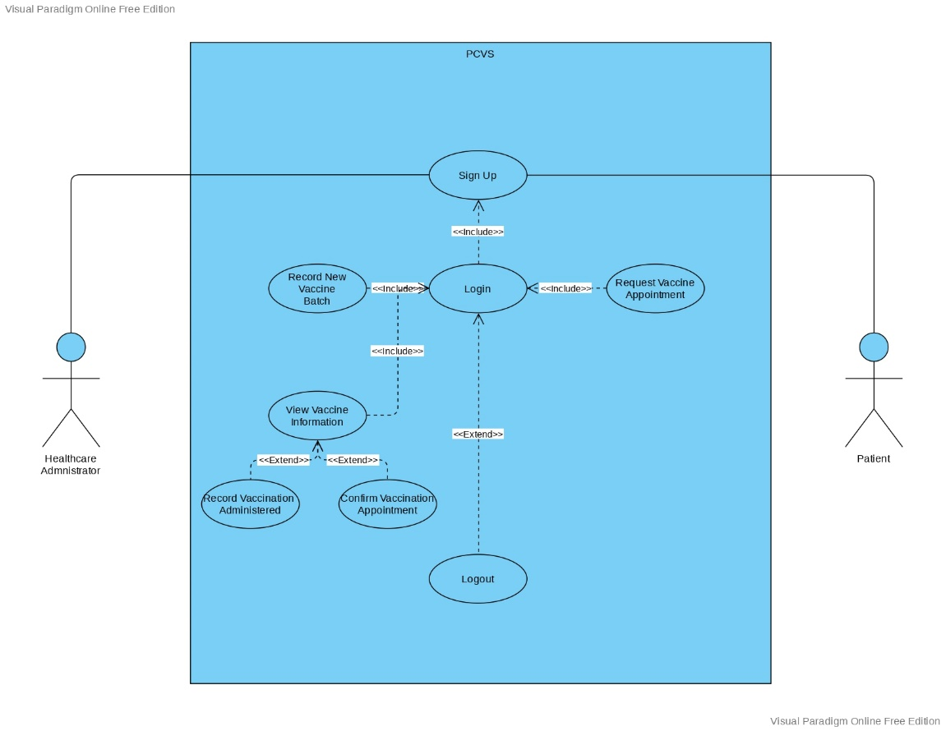

The use case diagram was not altered in any way. The use case diagram utilized in the previous requirement specification document is still the same. Our use case diagram still includes eight use cases: sign up, login, and logout for both user roles, record new vaccine batch, view vaccine information, record vaccination administered, and confirm vaccination appointment for healthcare administrators, and request vaccination appointment for patients. The use cases that we develop on this iteration are sign up, login, and logout.

## Requirements Specification

The requirements specification was not changed in any way. The requirements specification used in the previous requirement specification document is still the same. We will show the project's requirement specification that were previously created.

* Functional Requirements

|  |  |  |
| --- | --- | --- |
| No. | Requirements | User |
| 1. | A menu to sign up to the system | All |
| 2. | A menu to login to the system | All |
| 3. | Username/ID and password verification in login menu | All |
| 4. | Healthcare Administrator dashboard will be displayed after successfully login to the system | Healthcare Administrator |
| 5. | Record New Vaccine Batch menu to record new vaccine batch data from patient | Healthcare Administrator |
| 6. | View Vaccine Batch Information menu to show the information about vaccine batch that has been recorded | Healthcare Administrator |
| 7. | Record Vaccination Administered menu to record new data from patient who wants to do vaccinate | Healthcare Administrator |
| 8. | Confirm Vaccination appointment menu to confirm patient vaccination appointment | Healthcare Administrator |
| 9. | Patient dashboard will be displayed after successfully login to the system | Patient |
| 10. | Request Vaccination appointment menu to make a new request for vaccination appointment. | Patient |
| 11. | Log out button to exit/logout from the system | All |

* Non-functional Requirements

|  |  |  |
| --- | --- | --- |
| No. | Requirements | Description |
| 1. | Availability | This system will be available for the majority of the time, with an unplanned downtime of no more than 5 hours per case. This system is also easily accessible to all citizens with internet and mobile device access. |
| 2. | Compatibility | This system must be functioning properly in a variety of browsers, or at least four of the most commonly used browsers, such as Chrome, Edge, Mozilla Firefox, and Safari. |
| 3. | Performance | The system must be able to quickly return the results that the user has requested. MY Private Vaccine should respond to user actions such as login, opening a new page, filling out data, and so on as quickly as possible and should not make the user wait longer than 10 seconds to access one of the menus |
| 4. | Reliability | This system will be used for an indefinite period of time, and it must be reliable during that time so that the chance of critical failures occurring during normal or heavy usage conditions remains below 10%. |
| 5. | Security | This system will have to be guaranteed safe so that it can avoid data breaches that compromise user privacy, all user data kept within the system will be protected against malware and any type of unauthorized access. |
| 6. | Usability | This system must be user-friendly, with simple navigation and design to avoid confusing users, including those who are unfamiliar with electronics. |

# Design Specification

## Class Diagram

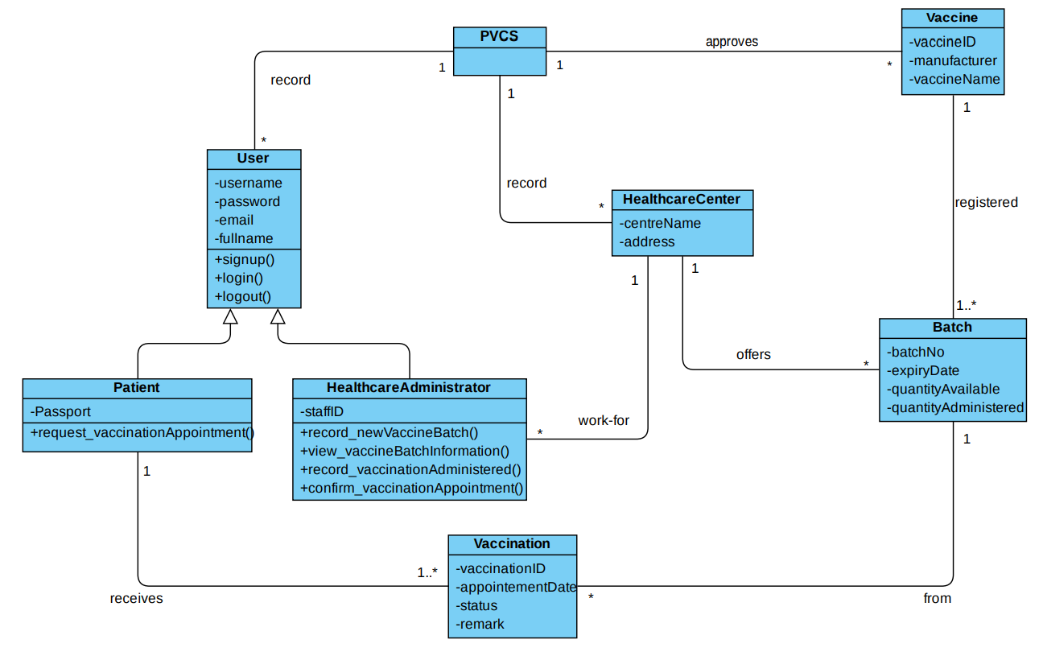

The class diagram was not altered in any way. The class diagram of use case developed for the first iteration utilized in the previous requirement specification document is still the same. The class diagram may or may not be affected by the remaining use cases developed in the project's second iteration. subsequent iteration documents will provide explanation if there any changes to the class diagram for the remaining use cases.

## ERD

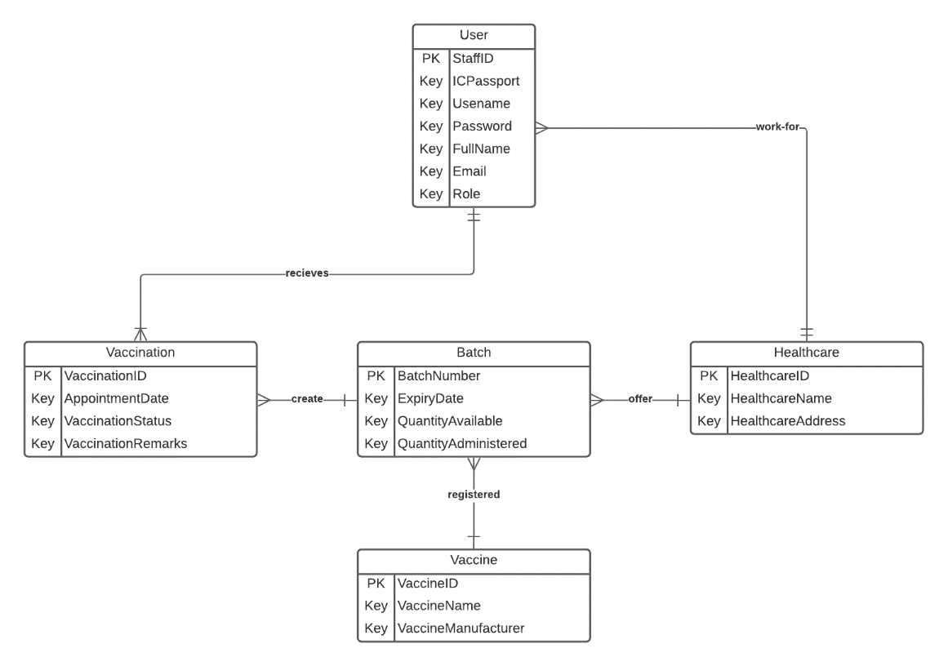

## Site Map

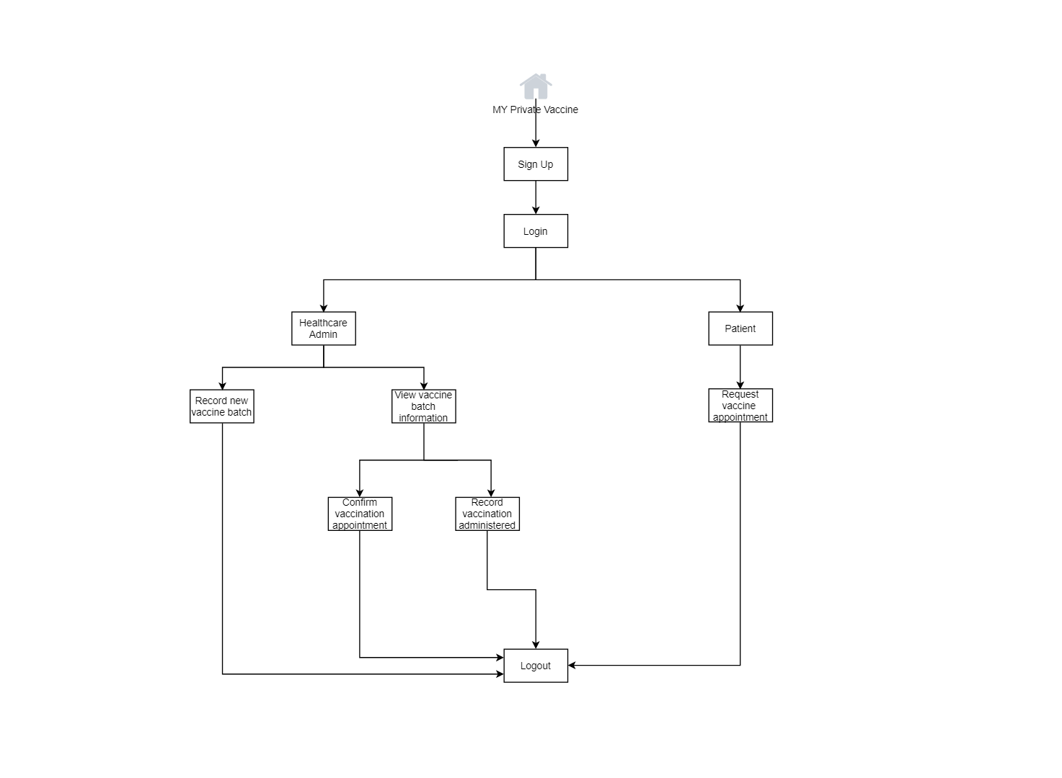

## Generic User Experience/Wireframe

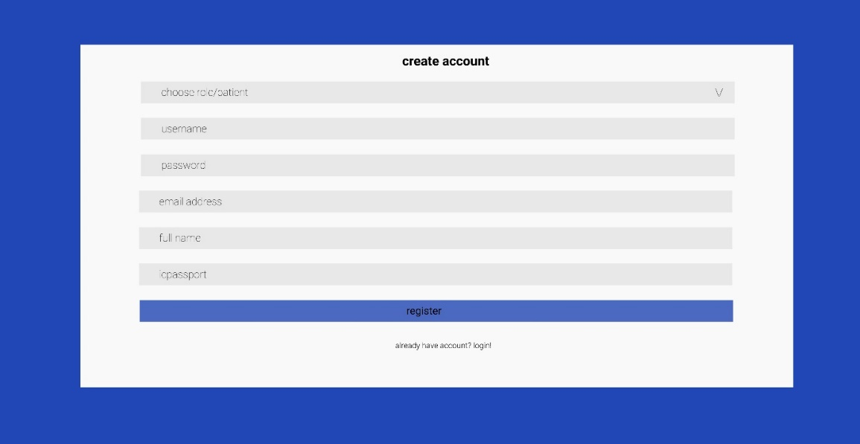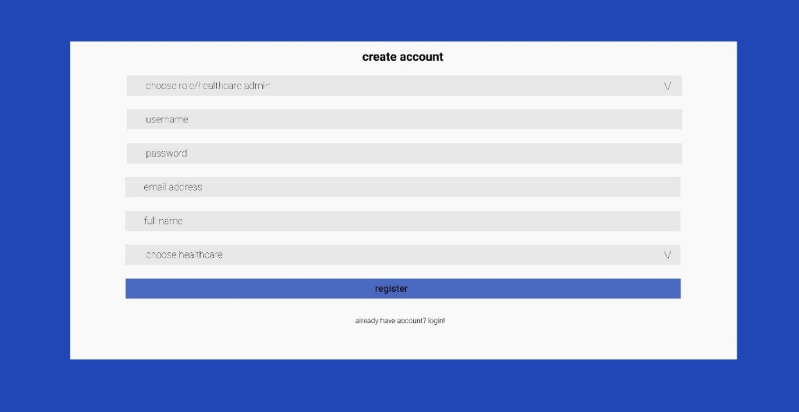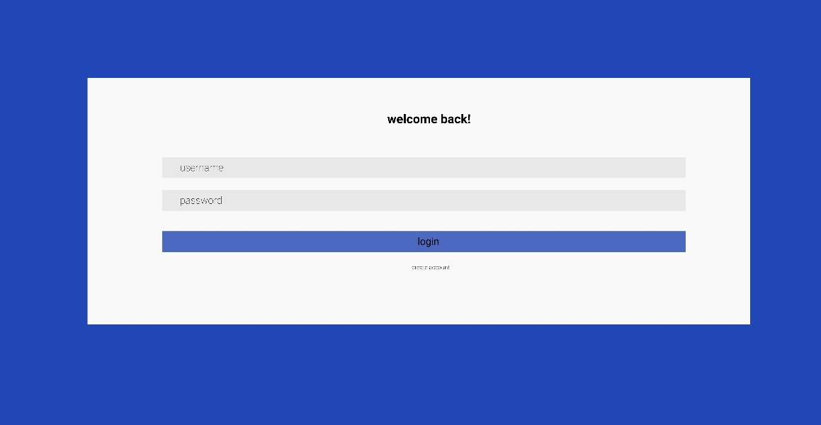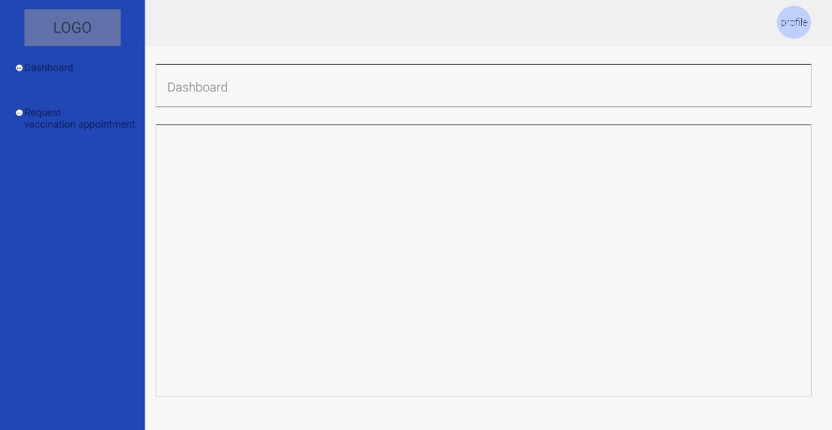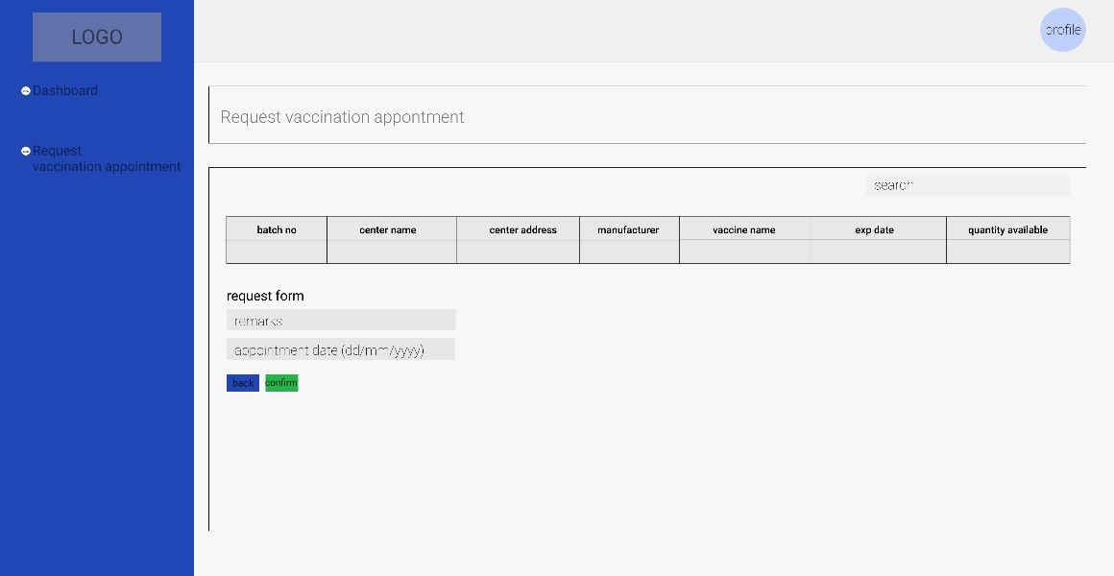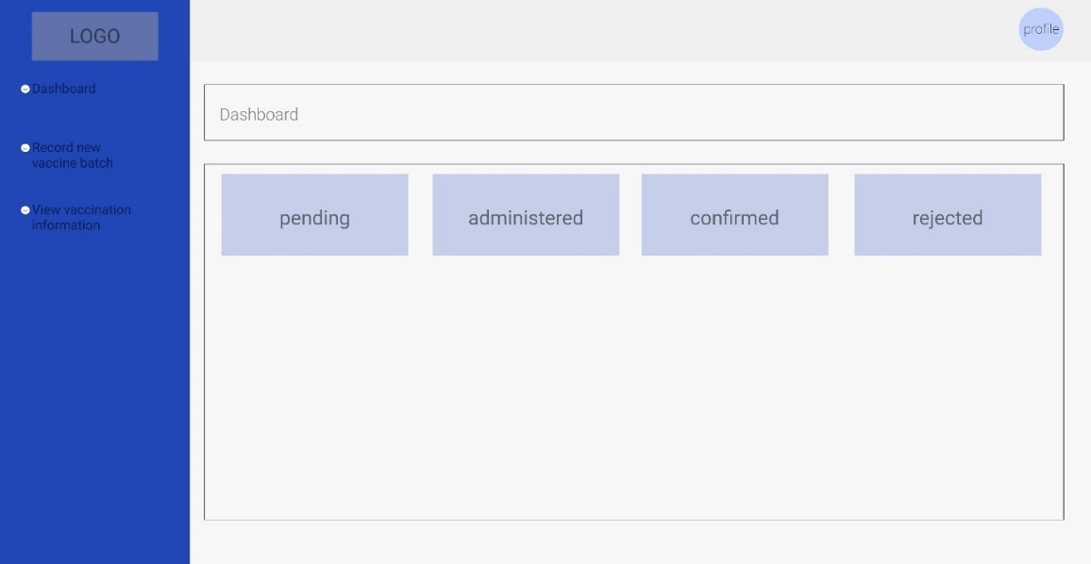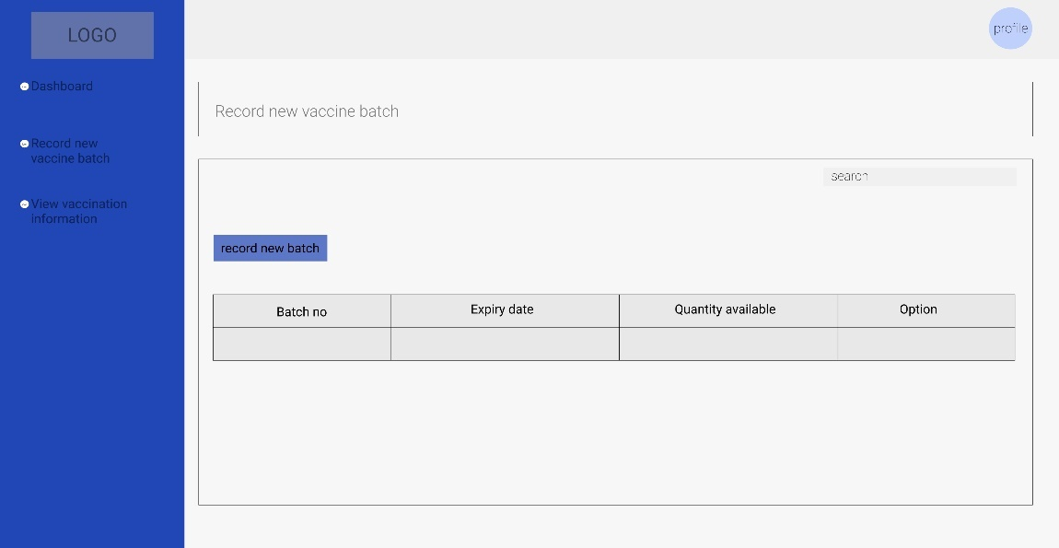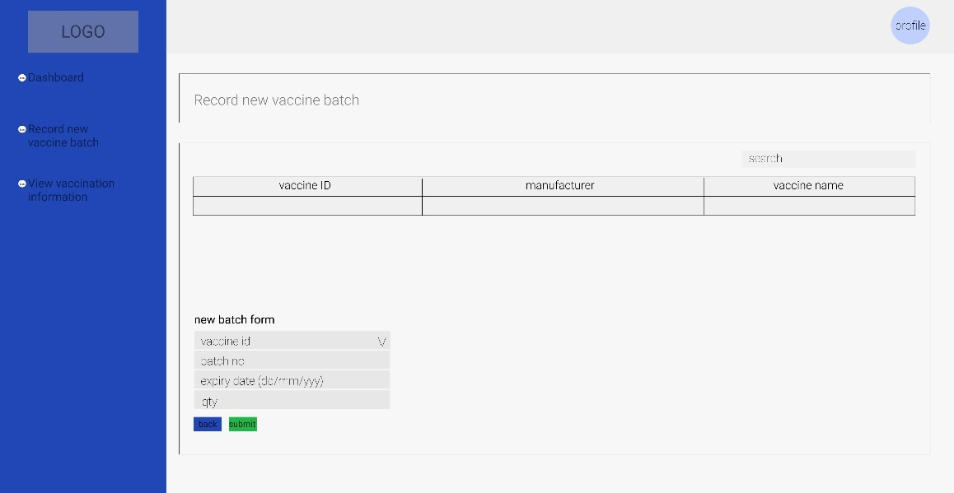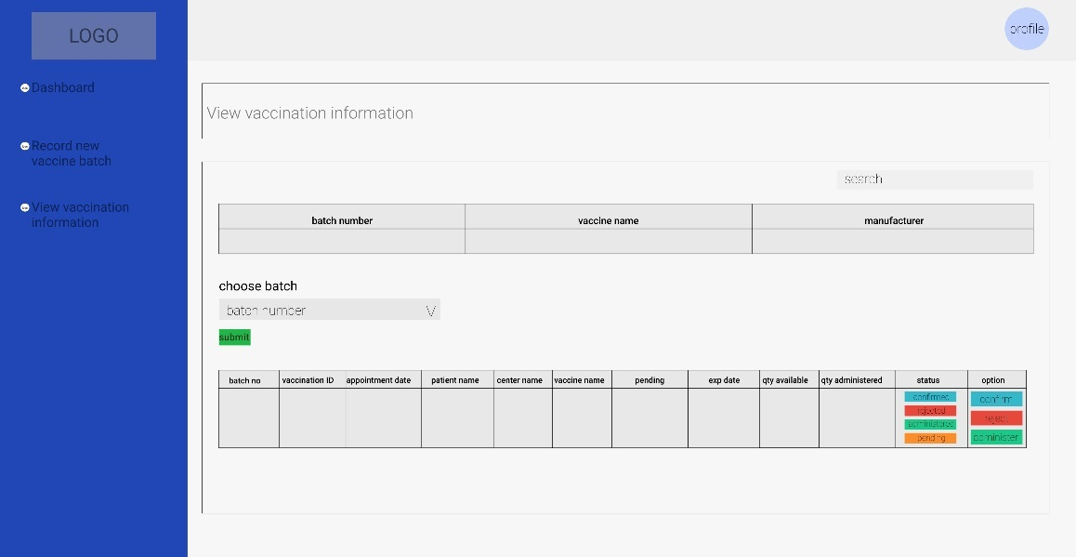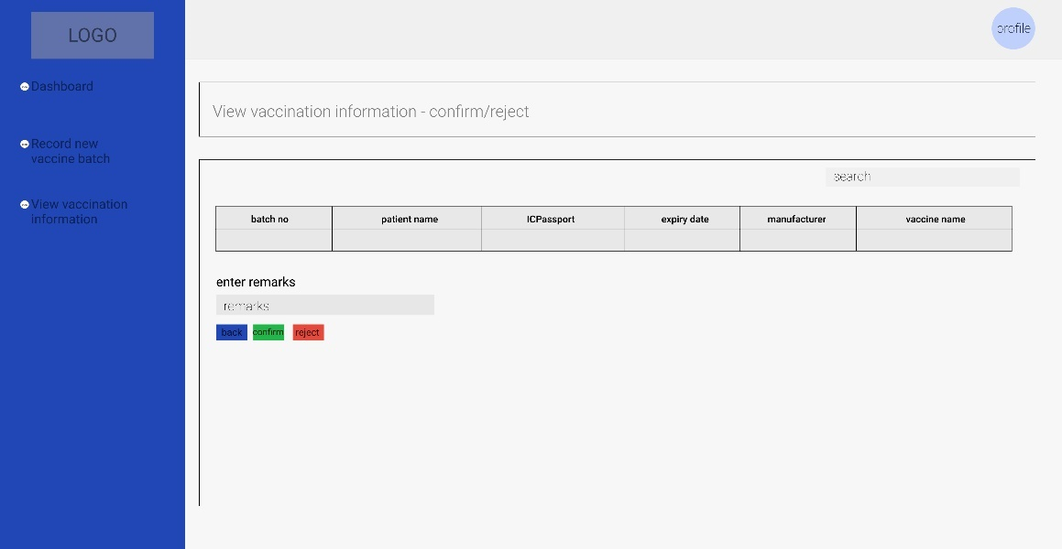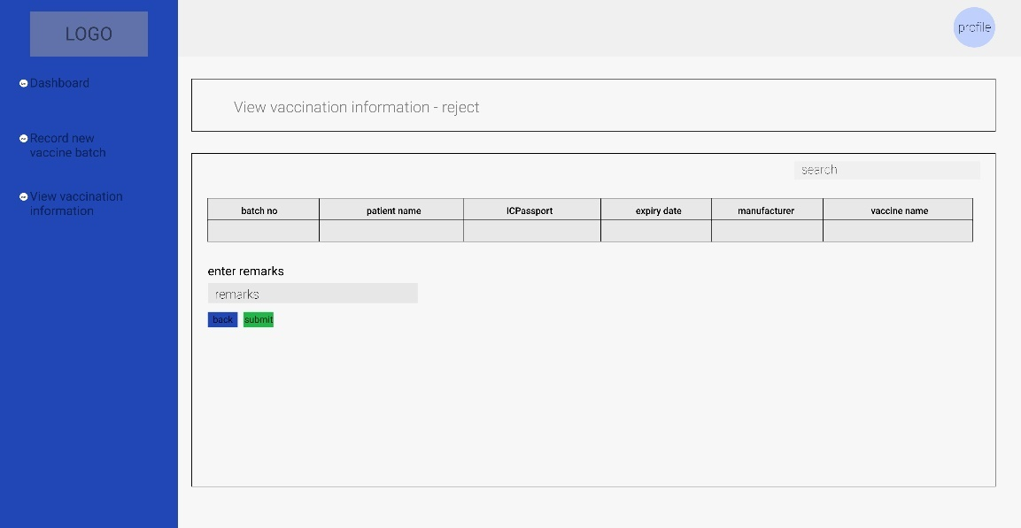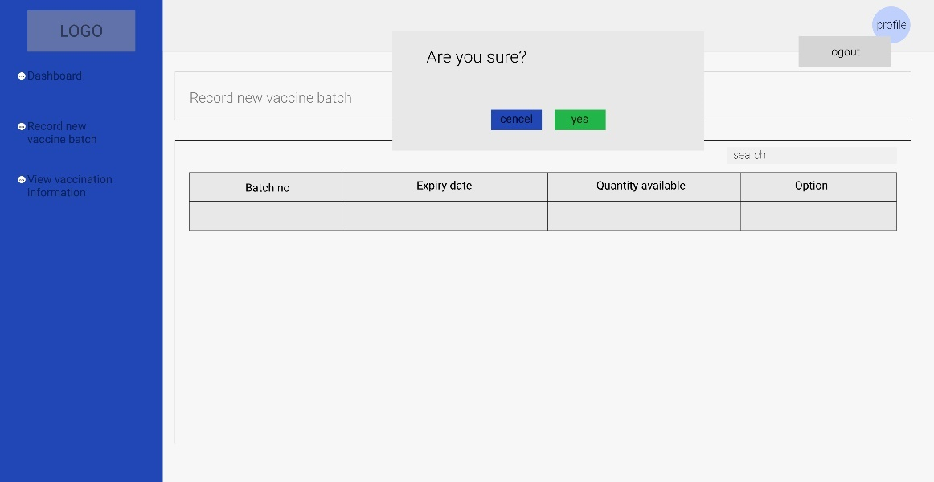

## System design of the system

1. Sign Up

* SSD

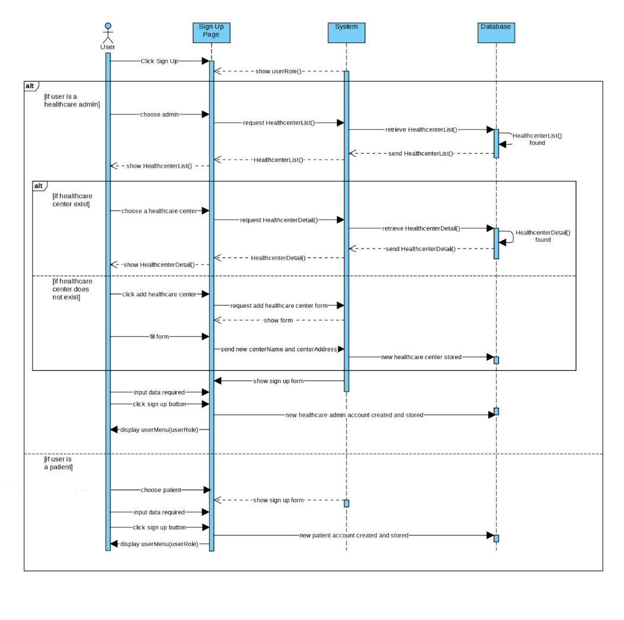

* Contracts

|  |  |
| --- | --- |
| **Cross References** | **Sign Up for Patient** |
| Operation | Signup(username, password, email, fullName, ICPassport) |
| Responsible | To allow potential patient to sign up |
| Pre-conditions | * A valid and active email exist * ICPassport registered |
| Post-conditions | * Patient account created * Directed to patient menu page |
| **Cross References** | **Sign Up for Healthcare Administrator** |
| Operation | Signup(username, password, email, fullName, staffID) |
| Responsible | To allow potential healthcare administrator to sign up |
| Pre-conditions | * A valid and active email exist * Registered to a healthcare centre as a staff with valid staffID   **If** a healthcare centre is not listed  **then** add centerName and centerAddress |
| Post-conditions | * Healthcare administrator account created * Directed to healthcare administrator menu page |

1. Login

* SSD

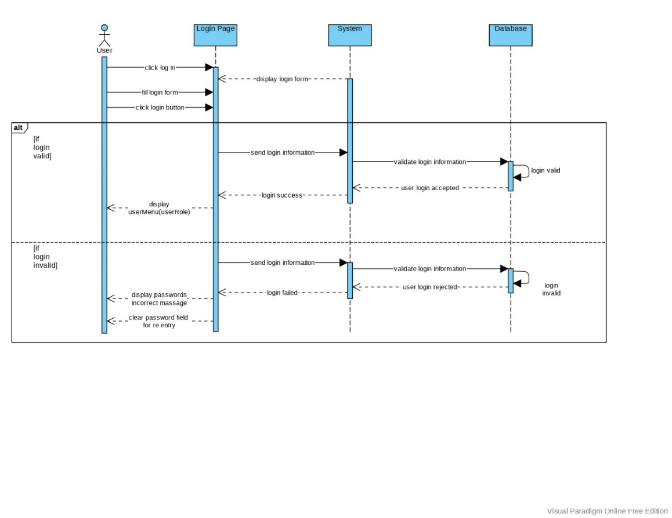

* Contracts

|  |  |
| --- | --- |
| **Cross References** | **Login** |
| Operation | Login(username, password) |
| Responsible | allow the user to access menu and feature according to the user's role |
| Pre-conditions | Username and password should valid |
| Post-conditions | **If** login valid   * Directed to healthcare administrator/patient menu page * Login session started   **Else**   * Clear password field for re-entry * Login session pending |

1. Logout

* SSD

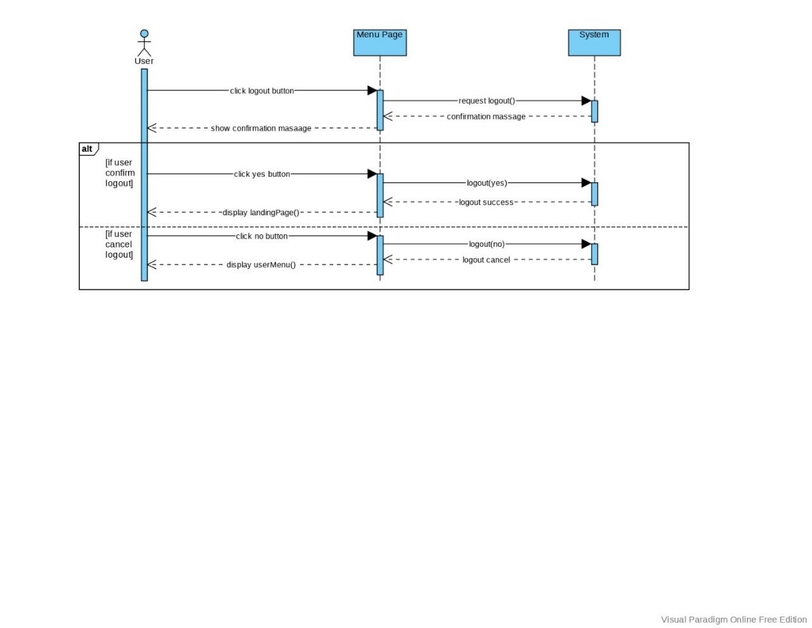

* Contracts

|  |  |
| --- | --- |
| **Cross References** | **Logout** |
| Operation | Logout() |
| Responsible | allow the user to logout from the system |
| Pre-conditions | * Session started * Click logout button |
| Post-conditions | **If** logout(yes)   * Click yes on the confirmation message * Login session ended   **Else**   * Click no on the confirmation message * Back to user menu |

## Database Design

1. User Table

|  |  |  |  |  |
| --- | --- | --- | --- | --- |
| Field Name | Data Type | Field | Description | Example |
| Id | Int | 5 | Administartor ID | 1 |
| icpassport | Varchar | 15 | Patient ICPassport | JPY5171014 |
| centreName | Varchar | 30 | Centre name of healthcare centre | MSU Medical Centre |
| username | Varchar | 15 | Username of user | uzumaki |
| password | Varchar | 15 | Password of user | naruto123 |
| email | Varchar | 30 | Email of user | [narutouzumaki@gmail.com](mailto:narutouzumaki@gmail.com) |
| fullname | Varchar | 30 | Fullname of user | Naruto Uzumaki |
| role | enum |  | Role of user | Administrator |

1. Healthcare Center Table

|  |  |  |  |  |
| --- | --- | --- | --- | --- |
| Field Name | Data Type | Field | Description | Example |
| id | Int | 11 | Healthcare centre ID | 1 |
| centreName | Varchar | 30 | Centre name of healthcare centre | MSU Medical Centre |
| address | Varchar | 30 | Address of healthcare centre | Kuala Lumpur |

1. Vaccine Table

|  |  |  |  |  |
| --- | --- | --- | --- | --- |
| Field Name | Data Type | Field | Description | Example |
| vaccineId | Int | 5 | Vaccine ID | 1 |
| manufacturer | Varchar | 15 | Manufacturer of vaccine | Coronavac |
| vaccine_name | Varchar | 15 | Name of vaccine | Sinovac |

1. Batch Table

|  |  |  |  |  |
| --- | --- | --- | --- | --- |
| Field Name | Data Type | Field | Description | Example |
| batchNo | Varchar | 15 | Batch number of vaccine | 87Y679 |
| expiryDate | date |  | Expiry date of batch | 12/12/2021 |
| quantityAvailable | Int | 5 | Quantity available of batch | 100 |
| quantityAdministered | Int | 5 | Quantity administered of batch | 50 |
| vaccineID | Int | 11 | Vaccine ID | 1 |
| centreName | Varchar | 30 | Centre name of healthcare centre | MSU Medical Centre |

1. Vaccination Table

|  |  |  |  |  |
| --- | --- | --- | --- | --- |
| Field Name | Data Type | Field | Description | Example |
| vaccinationId | Int | 5 | Vaccination id | 1 |
| batchNo | Varchar | 15 | Batch number of vaccine | 87Y679 |
| appointmentDate | date |  | Appointment date of vaccination | 12/12/2021 |
| status | Varchar | 15 | Status of vaccination | Pending |
| remarks | Varchar | 50 | Remark of vaccination | This vaccine has not been accepted yet |
| fullname | Varchar | 30 | Full name of user | Naruto Uzumaki |

# Iteration 1

## Identification

As mentioned above, we develop the sign up, login, and logout use cases. All the use cases developed for this first iteration of the project is developed by Ni Putu Zara Athifa Wijana. For the remaining use cases will be developed on the second iteration.

Table below created to display iteration details

* Iteration 1

|  |  |  |
| --- | --- | --- |
| No. | Use Case | Develop by |
| 1. | Sign Up | Ni Putu Zara Athifa Wijana |
| 2. | Login | Ni Putu Zara Athifa Wijana |
| 3. | Logout | Ni Putu Zara Athifa Wijana |

* Iteration 2

|  |  |  |
| --- | --- | --- |
| No. | Use Case | Develop by |
| 1. | Request vaccine appointment | Ni Putu Zara Athifa Wijana |
| 2. | Record new vaccine batch | Ni Putu Zara Athifa Wijana |
| 3. | View vaccine information | Muthia Kartika Putri |
| 4. | Record vaccination administered | Muthia Kartika Putri |
| 5. | Confirm vaccination appointment | Muthia Kartika Putri |

## Test Objectives

The testing procedure is carried out to ensure that the use cases developed in the first iteration of the project perform as expected. The following are all of the requirements' objectives for the three use cases that have been developed:

* Register both the patient and the healthcare provider.
* Users can logout of the system
* Directs users to their role menu page based on the username and password entered.
* System can be utilized on a variety of devices
* The user interface operates in accordance with its functions.

## Test Plan

|  |  |  |  |
| --- | --- | --- | --- |
| Testing type | Strategy | Tools | Schedule |
| Unit:  1. Sign Up  2. Login  3. Logout | Black box | Selenium | according to the gantt chart's schedule  (11/30/2021 – 12/01/2020) |
| Integration | Black box | Selenium | according to the gantt chart's schedule  (12/01/2021 – 12/01/2020) |
| Functional | Black box | Selenium | according to the gantt chart's schedule  (12/01/2021 – 12/01/2020) |
| Non-functional | Black box | Google Chrome | according to the gantt chart's schedule  (12/02/2021 – 12/02/2020) |

## Test Results

### Unit Testing

* Sign Up (Patient)

|  |  |  |  |  |  |
| --- | --- | --- | --- | --- | --- |
| Test ID | R-01 | | | | |
| Use Case | Sign Up (patient) | | | | |
| Test Description | To allow user(patient) to register to the system | | | | |
| Source Code |  | | | | |
|  | | Test Data | Expected output | Actual output | Remark(s) |
| Test case 1: | | * Username: uchiha * Password: sasuke123 * Email: uchihasasuke@gmail.com * Full Name: Uchiha Sasuke * ICPaspport: JPY5671234 | Success message displayed, direct user to login menu, data enter will be stored in the database. | Success message displayed, direct user to login menu, data enter will be stored in the database. | pass |
| Test case 2: | | * Username: * Password: * Email: * Full Name: * ICPaspport: | Warning message displayed, stay on the sign up page | Warning message displayed, stay on the sign up page | pass |
| Test case 3: | | * Username: uchiha * Password: itachi123 * Email: itachiuchiha@gmail.com * Full Name: Itachi Uchiha   ICPaspport: JPY2648576 | Warning message indicate username used shown | Warning message indicate username used shown | pass |

* Sign Up (Healthcare Administrator)

|  |  |  |  |  |  |
| --- | --- | --- | --- | --- | --- |
| Test ID | R-02 | | | | |
| Use Case | Sign Up (healthcare administrator) | | | | |
| Test Description | To allow user(healthcare administrator) to register to the system | | | | |
| Source Code |  | | | | |
|  | | Test Data | Expected output | Actual output | Remark(s) |
| Test case 1: | | * Username: uzumaki * Password: naruto123 * Email: uzumakinaruto@gmail.com * Full Name: Naruto Uzumaki * Center Name: MSU Medical Centre | Success message displayed, direct user to login menu, data enter will be stored in the database. | Success message displayed, direct user to login menu, data enter will be stored in the database. | Pass |
| Test case 2: | | * Username: * Password: * Email: * Full Name: * Center Name: | Warning message displayed, stay on the sign up page | Warning message displayed, stay on the sign up page | Pass |
| Test case 3: | | * Username: uzumaki * Password: boruto123 * Email: uzumakiboruto@gmail.com * Full Name: Boruto Uzumaki * Center Name: MSU Medical Centre | Warning message indicate username used shown | Warning message indicate username used shown | pass |

* Login

|  |  |  |  |  |  |
| --- | --- | --- | --- | --- | --- |
| Test ID | R-03 | | | | |
| Use Case | Login | | | | |
| Test Description | To allow user to login to the system and display their menu according to their role | | | | |
| Source Code |  | | | | |
|  | | Test Data | Expected output | Actual output | Remark(s) |
| Test case 1: | | * Username: uchiha * Password: sasuke123 | Direct to patient home page | Direct to patient home page | Pass |
| Test case 2: | | * Username: uzumaki * Password: naruto123 | Direct to healthcare administrator home page, display center name | Direct to healthcare administrator home page, display center name | Pass |
| Test case 3: | | * Username: uzumaki * Password: naruto | Display error notification, stay on login page, both field emptied | Display error notification, stay on login page, both field emptied | Pass |

* Logout

|  |  |  |  |  |  |
| --- | --- | --- | --- | --- | --- |
| Test ID | R-04 | | | | |
| Use Case | Logout | | | | |
| Test Description | To allow user to logout from the system | | | | |
| Source Code |  | | | | |
|  | | Test Data | Expected output | Actual output | Remark(s) |
| Test Case 1: | | Click logout button | Confirmation message displayed | Confirmation message displayed | Pass |
| Test Case 2: | | Click ‘cancel’ button on the logout confirmation | Stay on the pervious page | Stay on the pervious page | Pass |
| Test Case 3: | | Click ‘yes’ button on the logout confirmation | Session ended, directing back to login menu | Session ended, directing back to login menu | Pass |

### Integration Testing

We use Selenium IDE in the Chrome Browser to run the integration testing of use cases develop on the first iteration. The test results were saved as a Java file (.java).

* Sign Up (Patient)

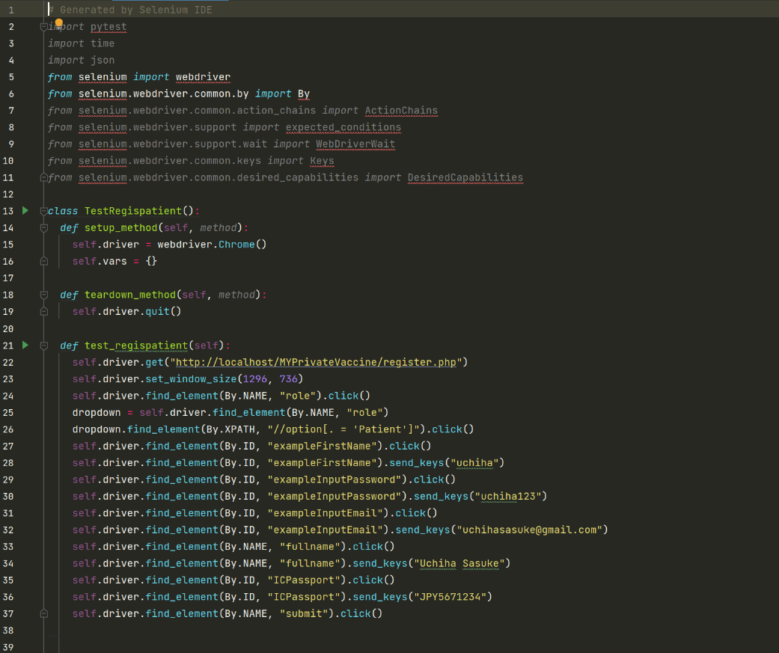

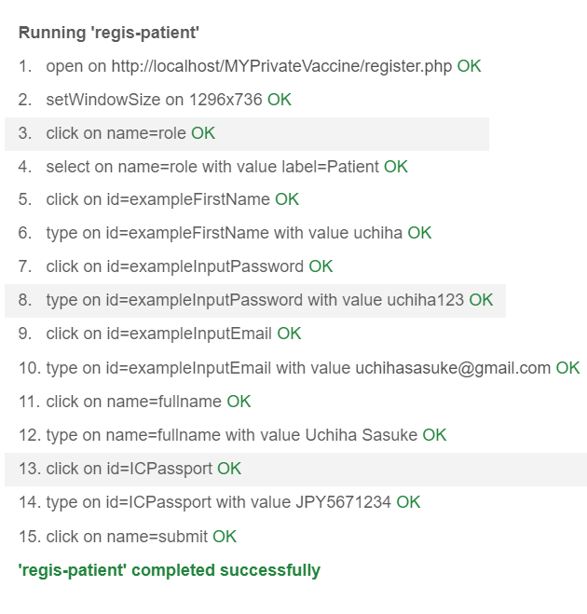

|  |  |  |  |  |  |
| --- | --- | --- | --- | --- | --- |
| Test ID | R-01 | | | | |
| Use Case | Sign Up (patient) | | | | |
| Test Description | To allow user(patient) to register to the system | | | | |
|  | | Test Data | Expected output | Actual output | Remark(s) |
| Test case 1: | | * Username: uchiha * Password: sasuke123 * Email: uchihasasuke@gmail.com * Full Name: Uchiha Sasuke * ICPaspport: JPY5671234 | Success message displayed, direct user to login menu, data enter will be stored in the database. | Success message displayed, direct user to login menu, data enter will be stored in the database. | pass |
| Test case 2: | | * Username: * Password: * Email: * Full Name: * ICPaspport: | Warning message displayed, stay on the sign up page | Warning message displayed, stay on the sign up page | pass |
| Test case 3: | | * Username: uchiha * Password: itachi123 * Email: itachiuchiha@gmail.com * Full Name: Itachi Uchiha * ICPaspport: JPY2648576 | Warning message indicate username used shown | Warning message indicate username used shown | pass |

* Sign Up (Healthcare Administrator)

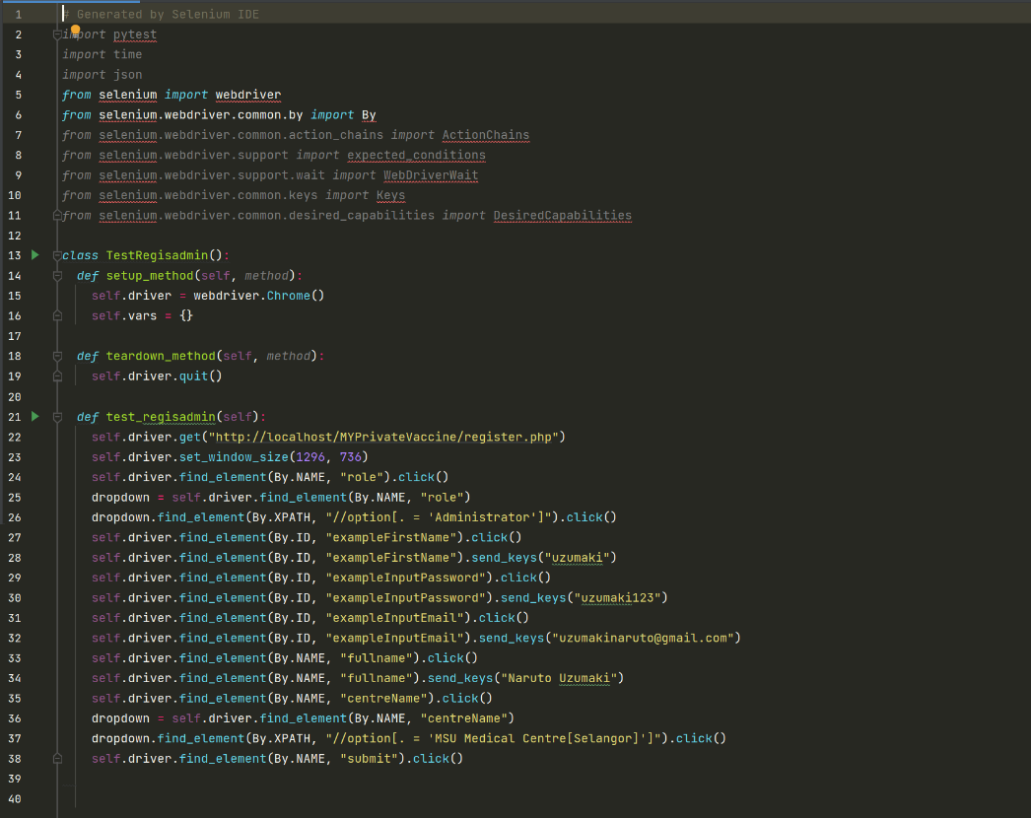

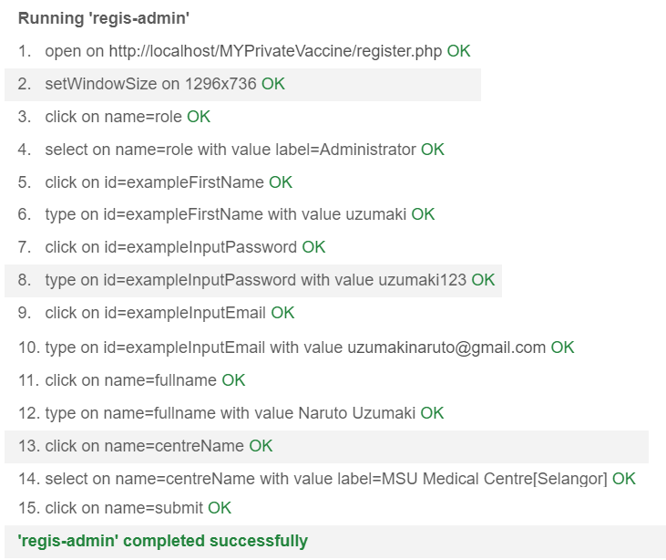

|  |  |  |  |  |  |
| --- | --- | --- | --- | --- | --- |
| Test ID | R-02 | | | | |
| Use Case | Sign Up (healthcare administrator) | | | | |
| Test Description | To allow user(healthcare administrator) to register to the system | | | | |
|  | | Test Data | Expected output | Actual output | Remark(s) |
| Test case 1: | | * Username: uzumaki * Password: naruto123 * Email: uzumakinaruto@gmail.com * Full Name: Naruto Uzumaki * Center Name: MSU Medical Centre | Success message displayed, direct user to login menu, data enter will be stored in the database. | Success message displayed, direct user to login menu, data enter will be stored in the database. | Pass |
| Test case 2: | | * Username: * Password: * Email: * Full Name: * Center Name: | Warning message displayed, stay on the sign up page | Warning message displayed, stay on the sign up page | Pass |
| Test case 3: | | * Username: uzumaki * Password: boruto123 * Email: uzumakiboruto@gmail.com * Full Name: Boruto Uzumaki * Center Name: MSU Medical Centre | Warning message indicate username used shown | Warning message indicate username used shown | pass |

* Login

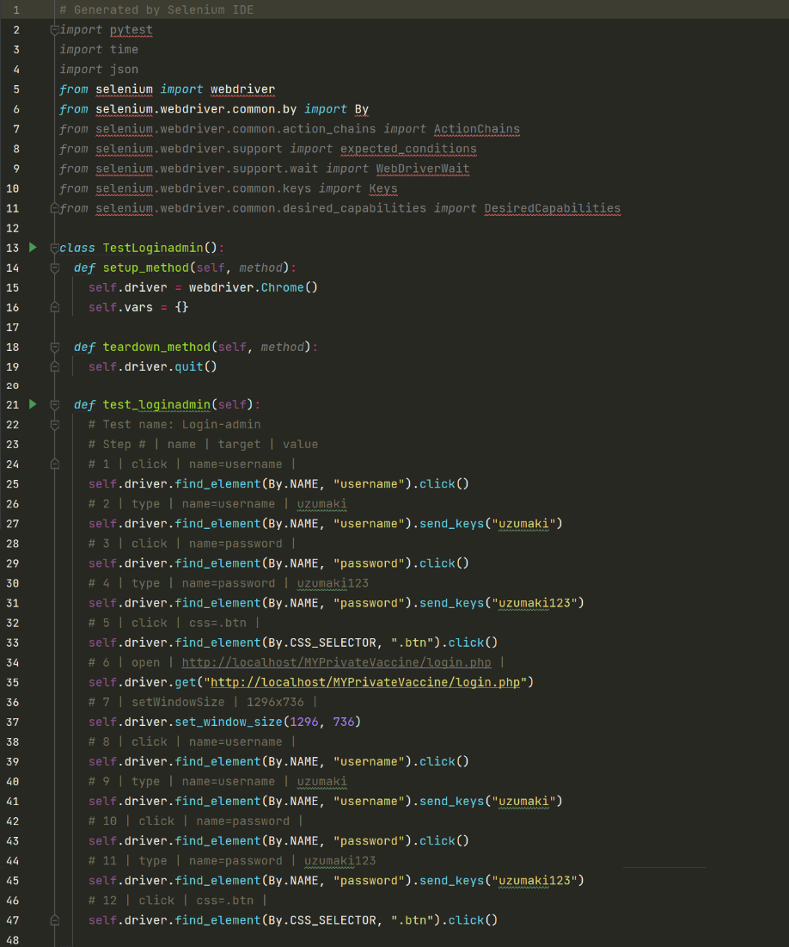

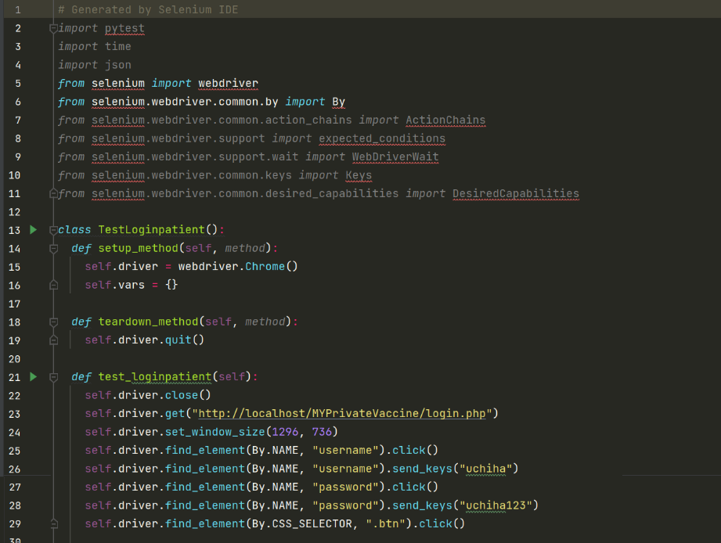

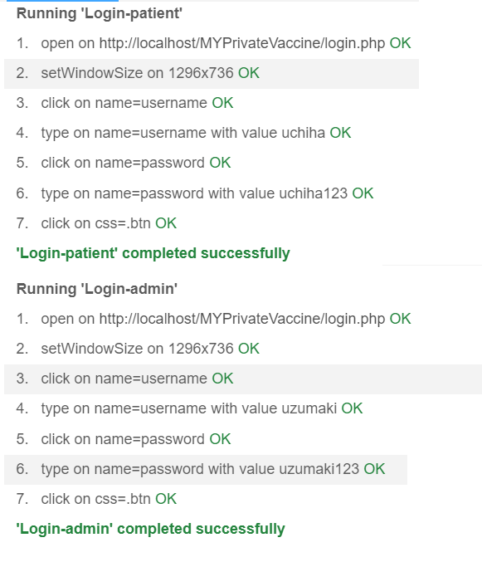

|  |  |  |  |  |  |
| --- | --- | --- | --- | --- | --- |
| Test ID | R-03 | | | | |
| Use Case | Login | | | | |
| Test Description | To allow user to login to the system and display their menu according to their role | | | | |
|  | | Test Data | Expected output | Actual output | Remark(s) |
| Test case 1: | | * Username: uchiha * Password: sasuke123 | Direct to patient home page | Direct to patient home page | Pass |
| Test case 2: | | * Username: uzumaki * Password: naruto123 | Direct to healthcare administrator home page, display center name | Direct to healthcare administrator home page, display center name | Pass |
| Test case 3: | | * Username: uzumaki * Password: naruto | Display error notification, stay on login page, both field emptied | Display error notification, stay on login page, both field emptied | Pass |

* Logout

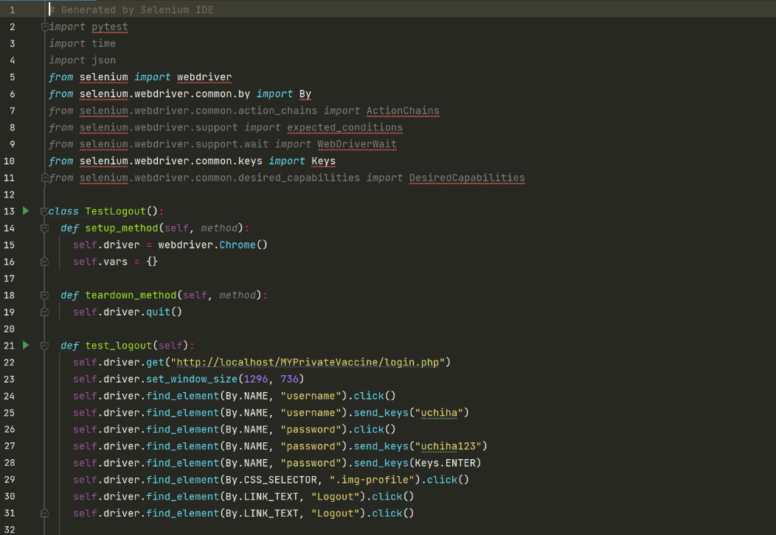

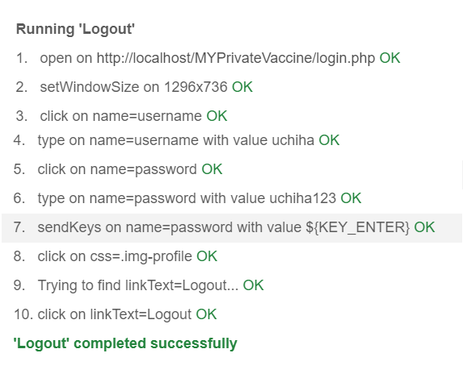

|  |  |  |  |  |  |
| --- | --- | --- | --- | --- | --- |
| Test ID | R-04 | | | | |
| Use Case | Logout | | | | |
| Test Description | To allow user to logout from the system | | | | |
|  | | Test Data | Expected output | Actual output | Remark(s) |
| Test Case 1: | | Click logout button | Confirmation message displayed | Confirmation message displayed | Pass |
| Test Case 2: | | Click ‘cancel’ button on the logout confirmation | Stay on the pervious page | Stay on the pervious page | Pass |
| Test Case 3: | | Click ‘yes’ button on the logout confirmation | Session ended, directing back to login menu | Session ended, directing back to login menu | Pass |

### System Testing

* Functional Requirements

1. Sign Up (Patient)
2. Below is the display for sign up, then user proceed to choose their role

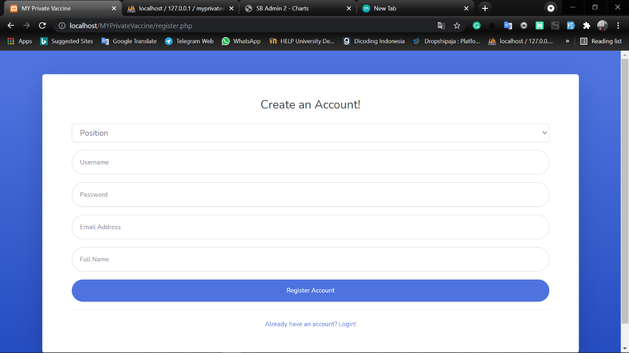

1. When patient input no data but click the register button

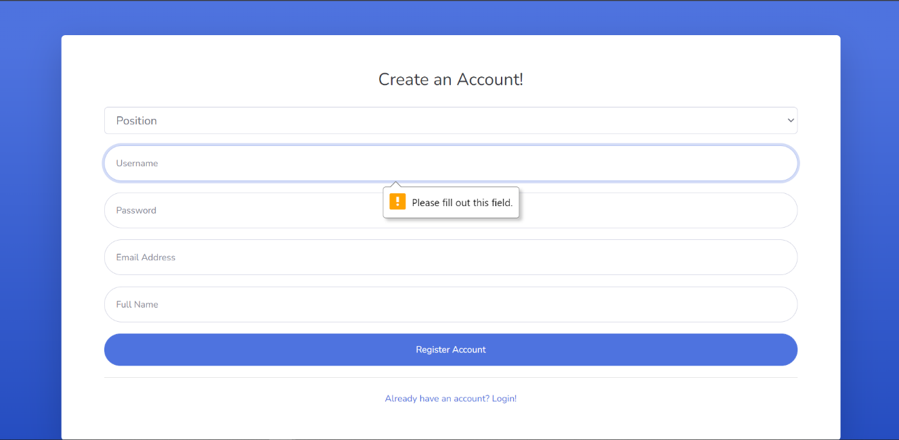

1. User then choose role, if user is a patient, the ICPassport field shown

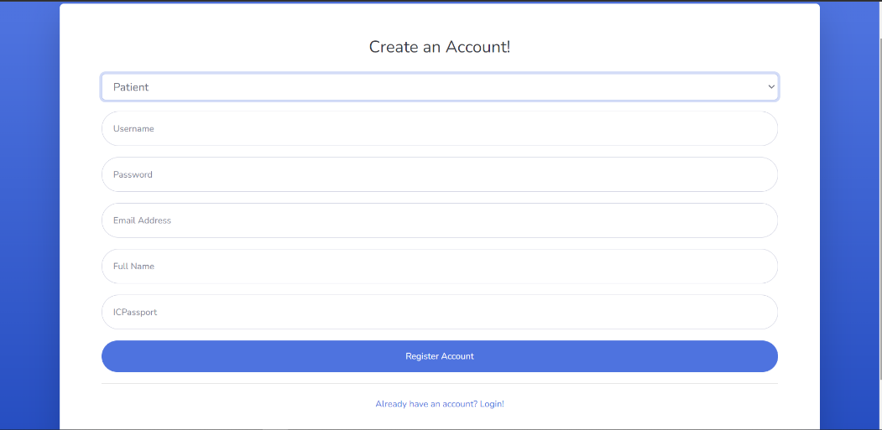

1. When a patient used an exist username

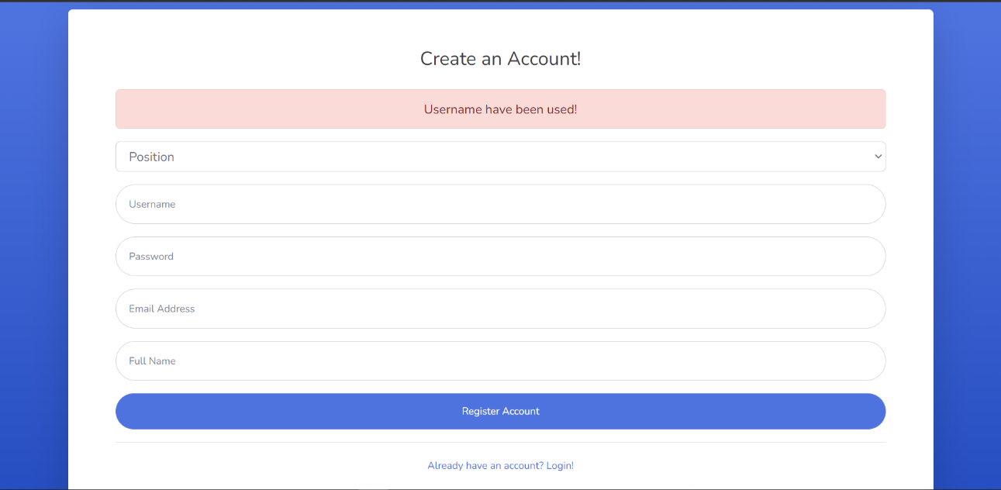

1. When patient input correct data required and click the register button, then login menu displayed.

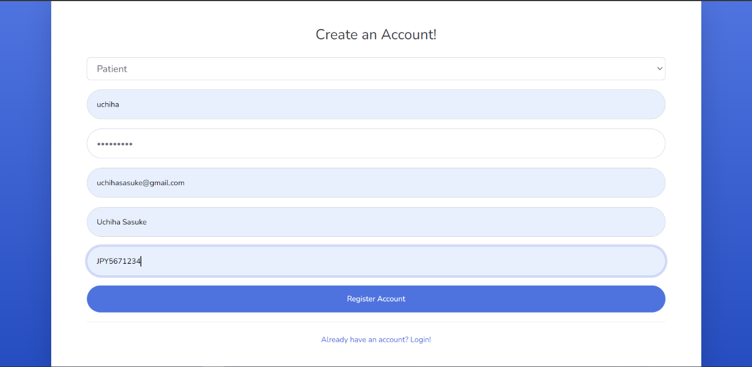

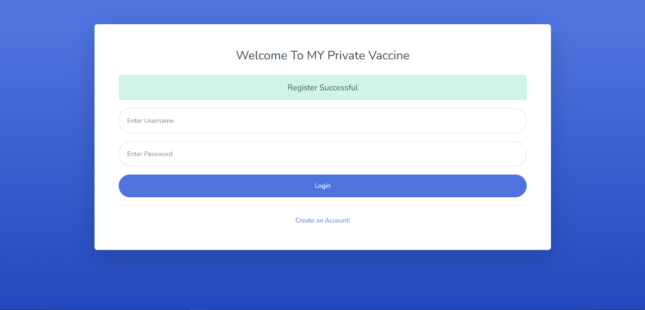

|  |  |  |  |  |  |
| --- | --- | --- | --- | --- | --- |
| Test ID | R-01 | | | | |
| Use Case | Sign Up (patient) | | | | |
| Test Description | To allow user(patient) to register to the system | | | | |
|  | | Test Data | Expected output | Actual output | Remark(s) |
| Test case 1: | | * Username: uchiha * Password: sasuke123 * Email: uchihasasuke@gmail.com * Full Name: Uchiha Sasuke * ICPaspport: JPY5671234 | Success message displayed, direct user to login menu, data enter will be stored in the database. | Success message displayed, direct user to login menu, data enter will be stored in the database. | pass |
| Test case 2: | | * Username: * Password: * Email: * Full Name: * ICPaspport: | Warning message displayed, stay on the sign up page | Warning message displayed, stay on the sign up page | pass |
| Test case 3: | | * Username: uchiha * Password: itachi123 * Email: itachiuchiha@gmail.com * Full Name: Itachi Uchiha * ICPaspport: JPY2648576 | Warning message indicate username used shown | Warning message indicate username used shown | pass |

1. Sign Up (Healthcare Administrator)
2. Below is the display for sign up, then user proceed to choose their role



1. When healthcare administrator input no data but click the register button



1. User then choose role, if user is a healthcare admin, the center name field shown, admin then choose a healthcare to assign

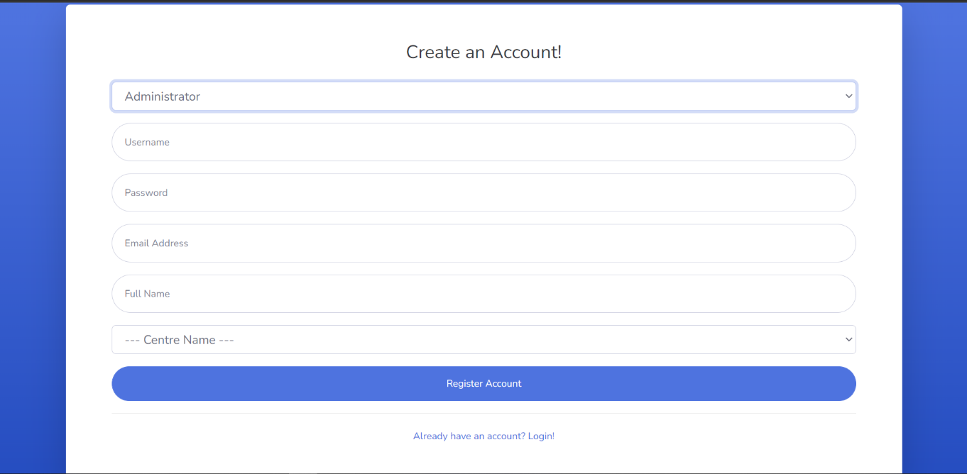

1. When a healthcare admin used an exist username



1. When healthcare admin input correct data required and click the register button, then login menu displayed.

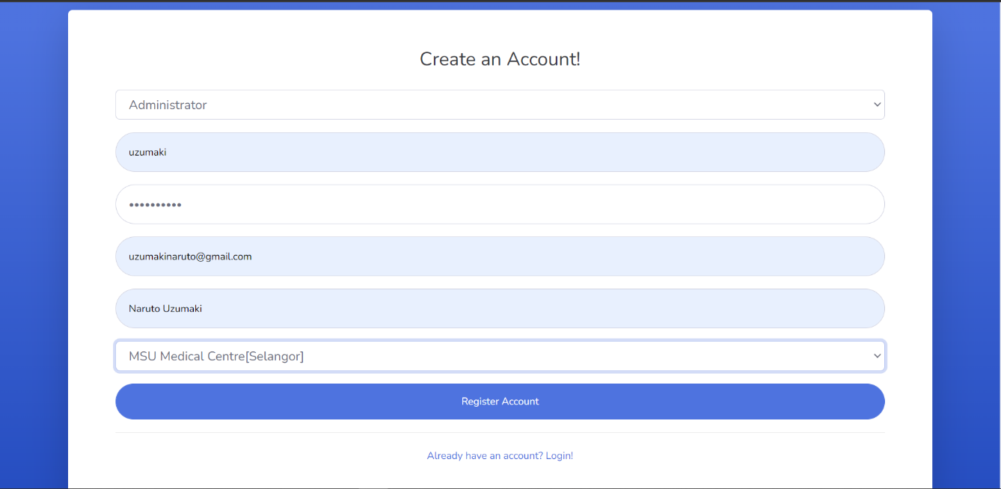

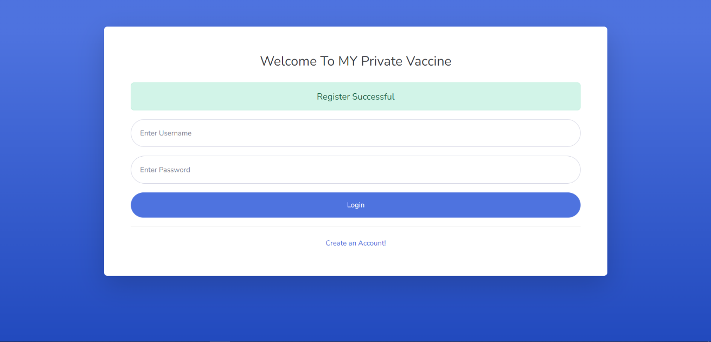

|  |  |  |  |  |  |
| --- | --- | --- | --- | --- | --- |
| Test ID | R-02 | | | | |
| Use Case | Sign Up (healthcare administrator) | | | | |
| Test Description | To allow user(healthcare administrator) to register to the system | | | | |
|  | | Test Data | Expected output | Actual output | Remark(s) |
| Test case 1: | | * Username: uzumaki * Password: naruto123 * Email: uzumakinaruto@gmail.com * Full Name: Naruto Uzumaki * Center Name: MSU Medical Centre | Success message displayed, direct user to login menu, data enter will be stored in the database. | Success message displayed, direct user to login menu, data enter will be stored in the database. | Pass |
| Test case 2: | | * Username: * Password: * Email: * Full Name: * Center Name: | Warning message displayed, stay on the sign up page | Warning message displayed, stay on the sign up page | Pass |
| Test case 3: | | * Username: uzumaki * Password: boruto123 * Email: uzumakiboruto@gmail.com * Full Name: Boruto Uzumaki * Center Name: MSU Medical Centre | Warning message indicate username used shown | Warning message indicate username used shown | pass |

1. Login
2. This is the login page

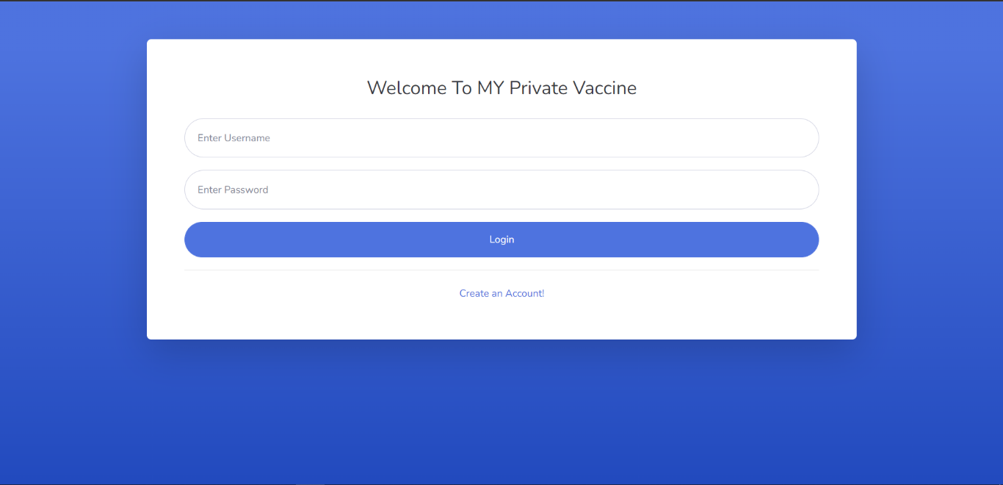

1. This is when user input no data but click login

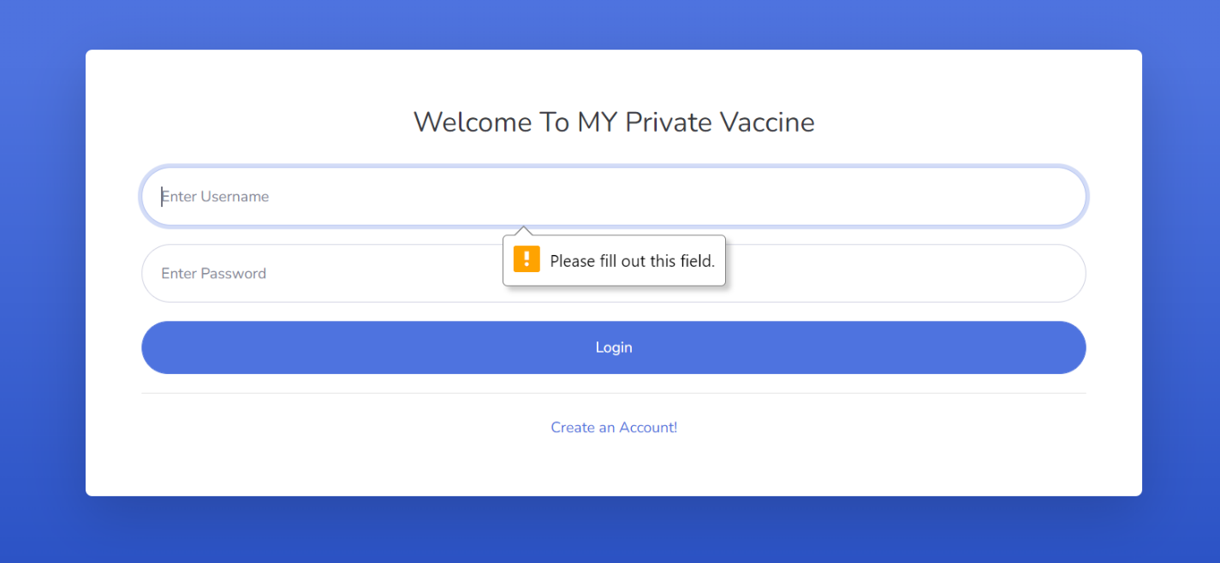

1. When user enter unmatched username and password

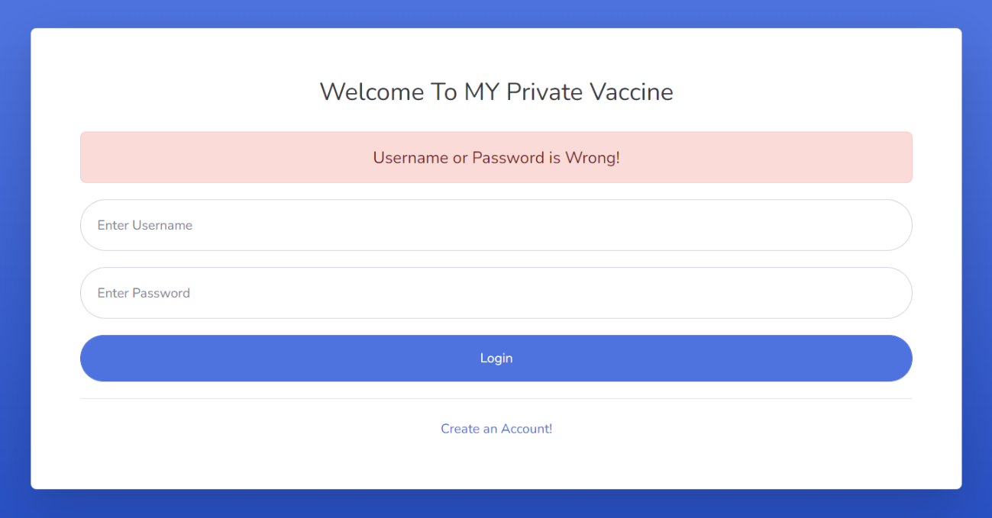

1. When patient enter match password and username, display menu based on their role

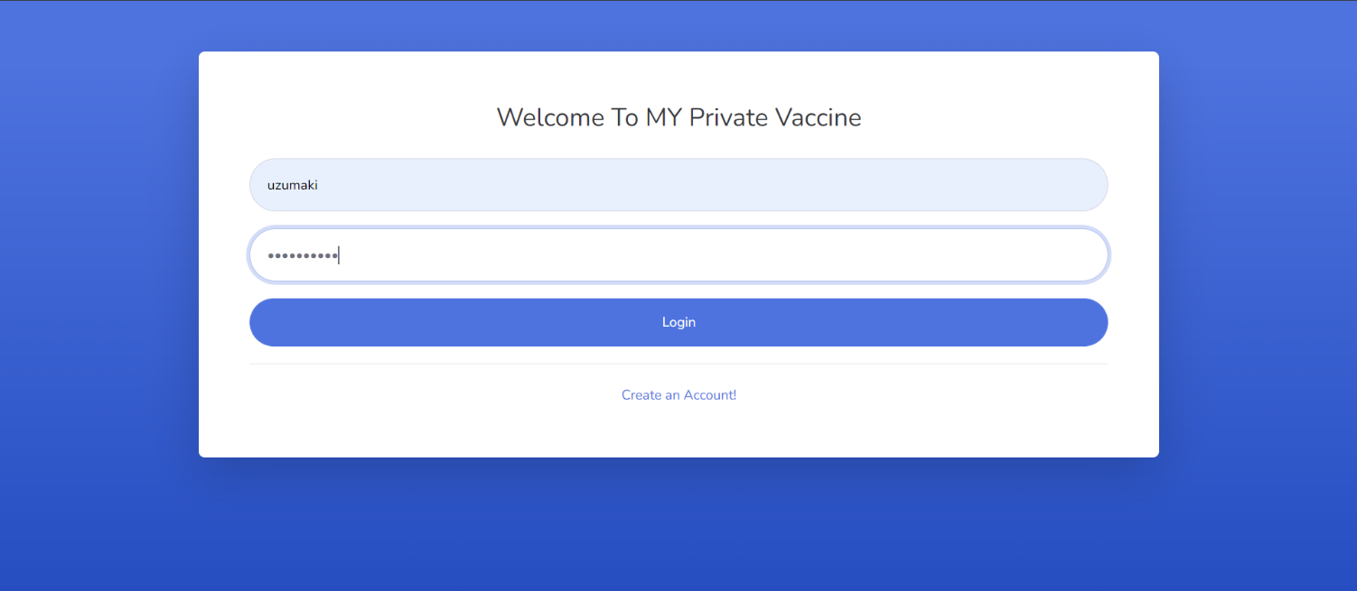

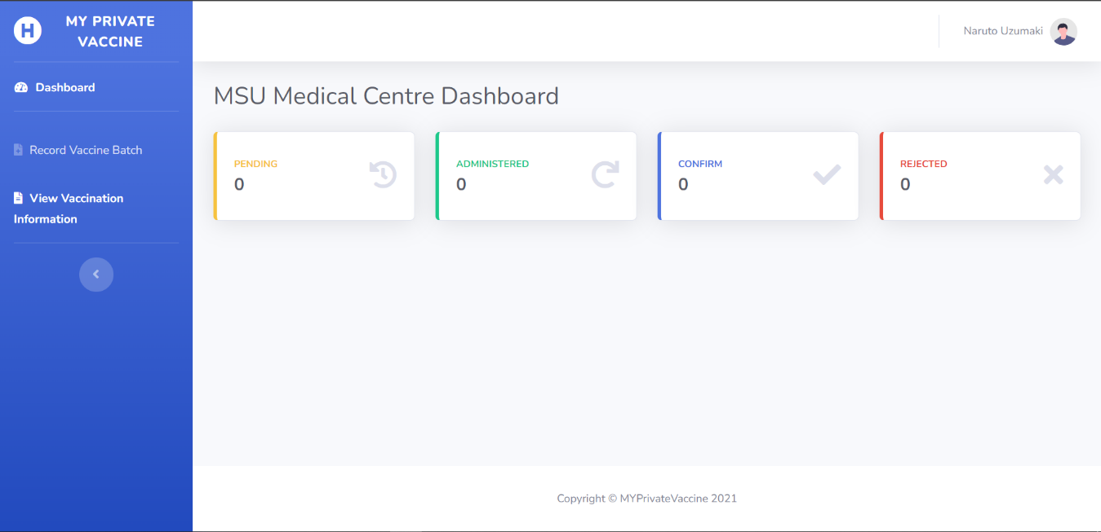

|  |  |  |  |  |  |
| --- | --- | --- | --- | --- | --- |
| Test ID | R-03 | | | | |
| Use Case | Login | | | | |
| Test Description | To allow user to login to the system and display their menu according to their role | | | | |
|  | | Test Data | Expected output | Actual output | Remark(s) |
| Test case 1: | | * Username: uchiha * Password: sasuke123 | Direct to patient home page | Direct to patient home page | Pass |
| Test case 2: | | * Username: uzumaki * Password: naruto123 | Direct to healthcare administrator home page, display center name | Direct to healthcare administrator home page, display center name | Pass |
| Test case 3: | | * Username: uzumaki * Password: naruto | Display error notification, stay on login page, both field emptied | Display error notification, stay on login page, both field emptied | Pass |

1. Logout
2. Logout button

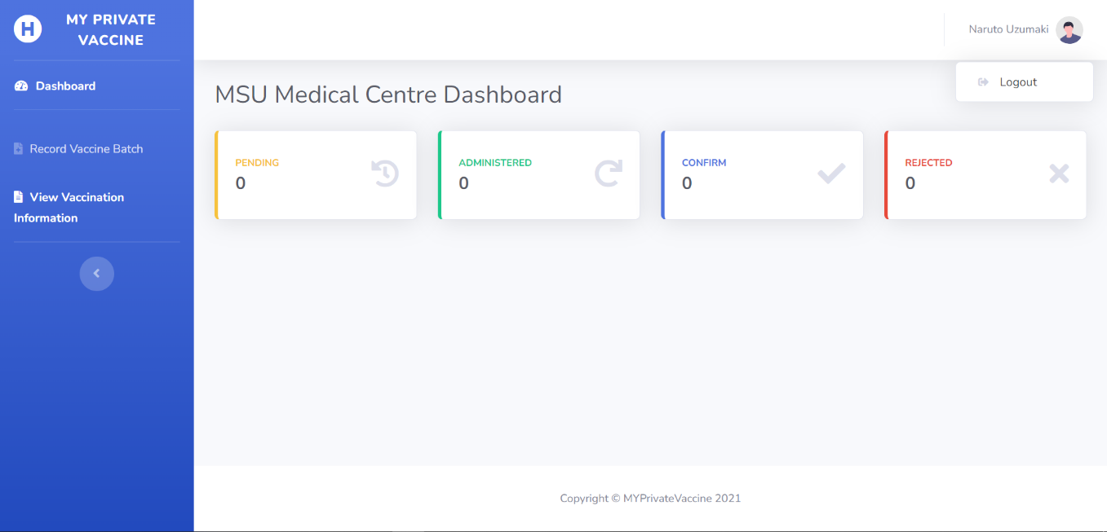

1. Logout confirmation

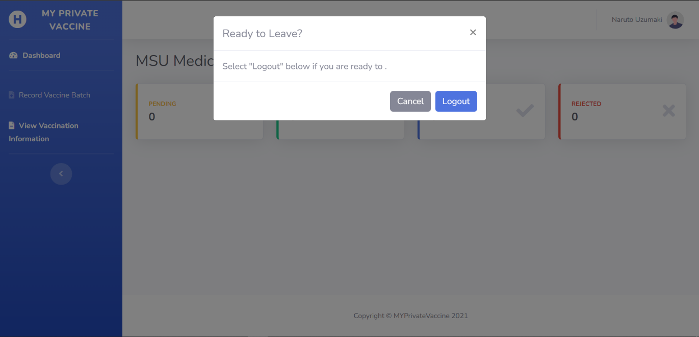

1. If user click yes, display login page

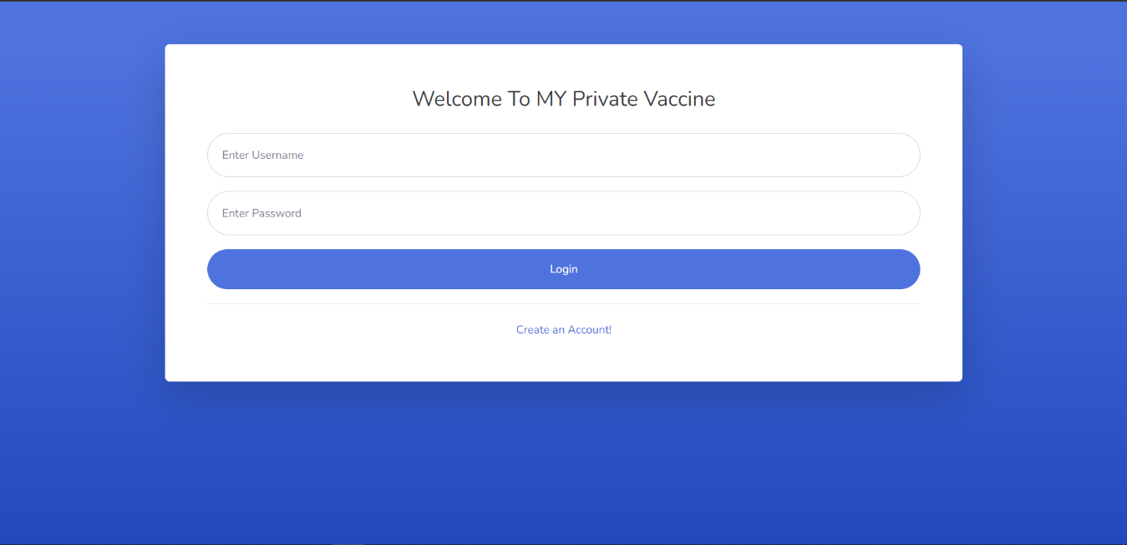

1. If user click cancel, confirmation notification disappear, user back to their last page



|  |  |  |  |  |  |
| --- | --- | --- | --- | --- | --- |
| Test ID | R-04 | | | | |
| Use Case | Logout | | | | |
| Test Description | To allow user to logout from the system | | | | |
|  | | Test Data | Expected output | Actual output | Remark(s) |
| Test Case 1: | | Click logout button | Confirmation message displayed | Confirmation message displayed | Pass |
| Test Case 2: | | Click ‘cancel’ button on the logout confirmation | Stay on the pervious page | Stay on the pervious page | Pass |
| Test Case 3: | | Click ‘yes’ button on the logout confirmation | Session ended, directing back to login menu | Session ended, directing back to login menu | Pass |

* Non-functional Requirements

1. Compatibility

Accessible to most browser, here we choose Microsoft Edge and Google Chrome as an example

* Microsoft Edge

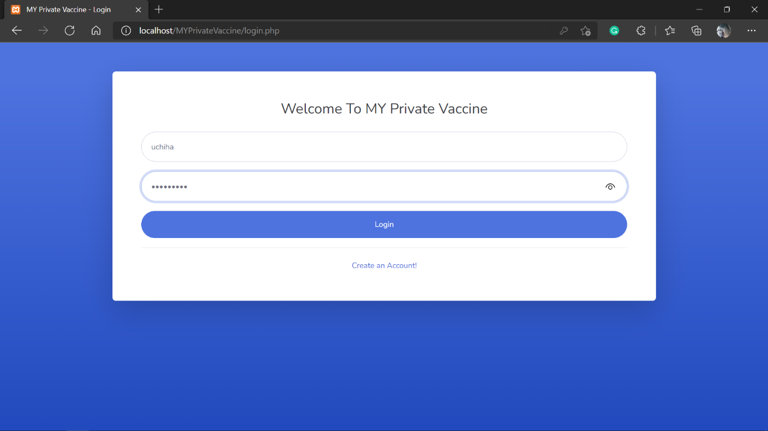

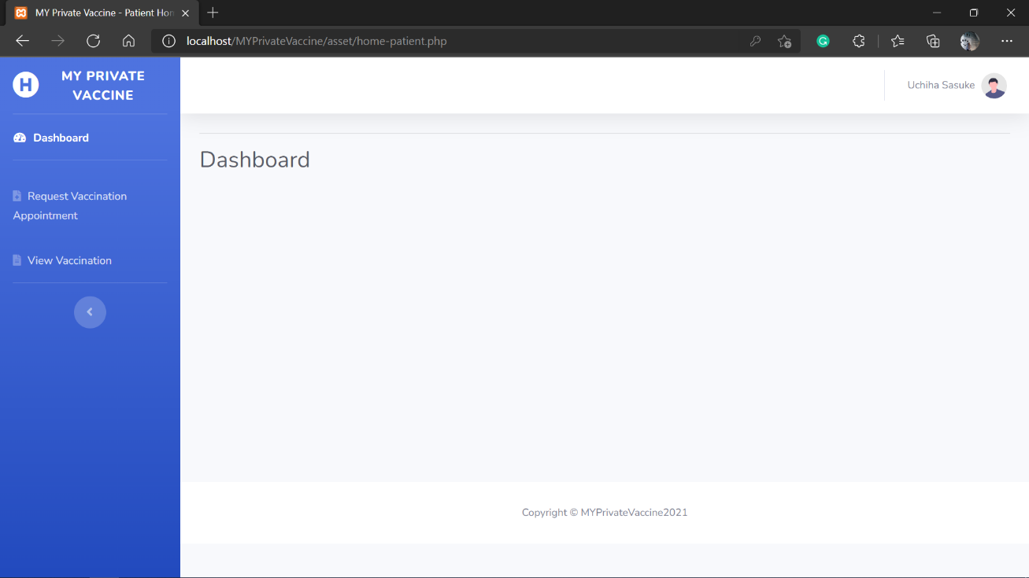

* Google Chrome

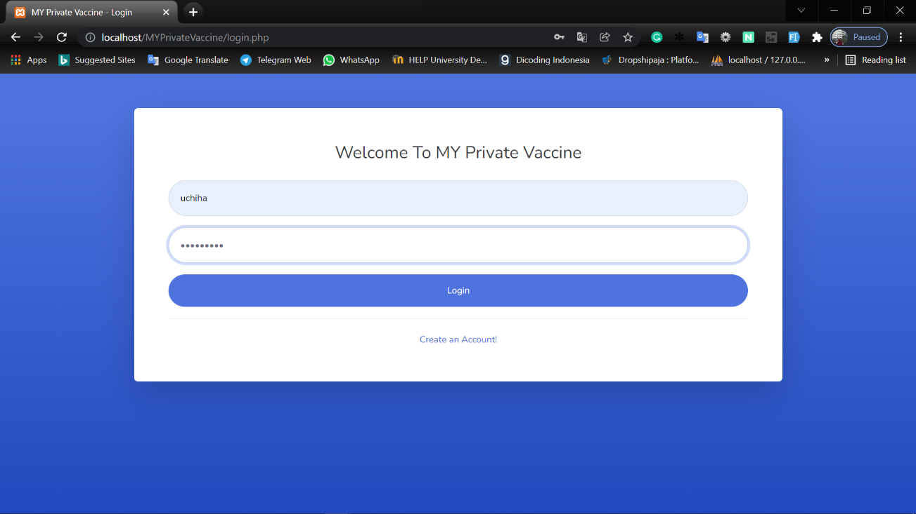

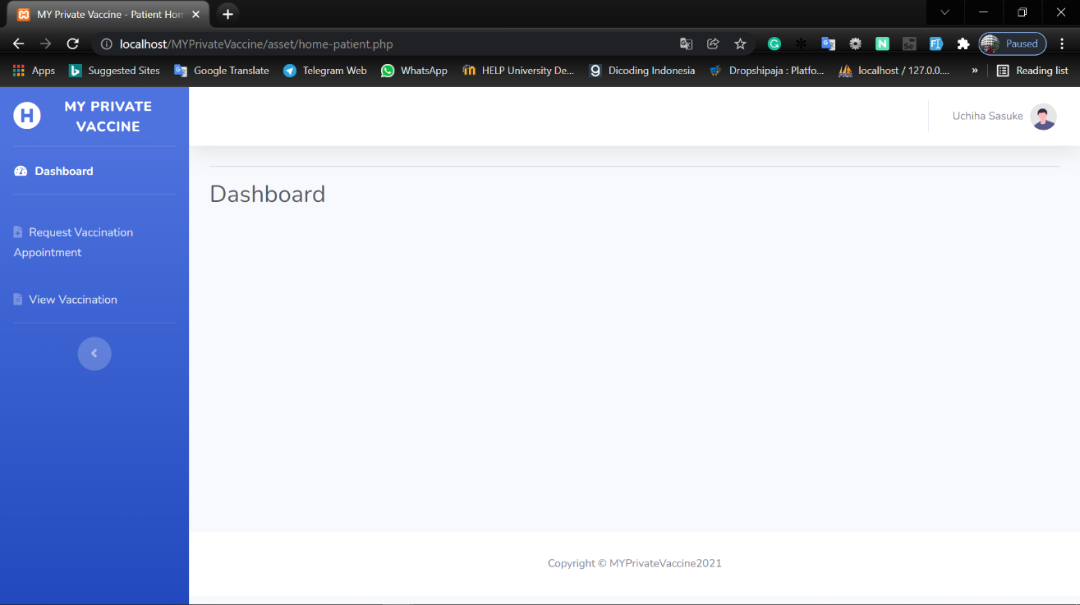

1. Security

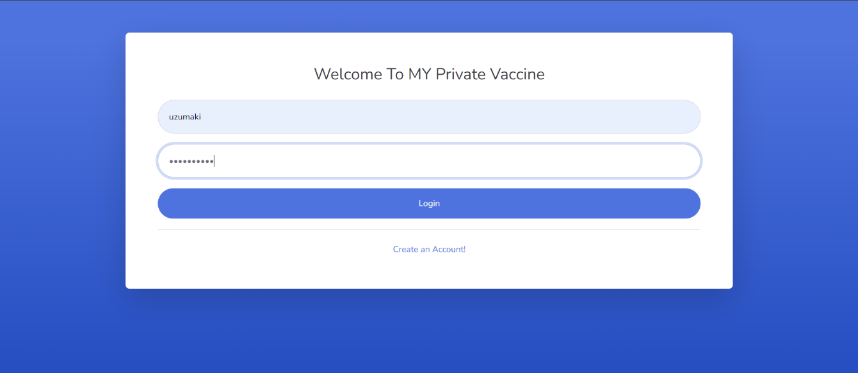

|  |  |  |  |  |  |
| --- | --- | --- | --- | --- | --- |
| Test ID | R-03 | | | | |
| Use Case | Login | | | | |
| Test Description | To allow user to login to the system and display their menu according to their role | | | | |
|  | | Test Data | Expected output | Actual output | Remark(s) |
| Test case 1: | | * Username: uchiha * Password: sasuke123 | Password field changed to “•••” | Password field changed to “•••” | Pass |

1. Usability

User friendly website with simple layout. Dashboard example.

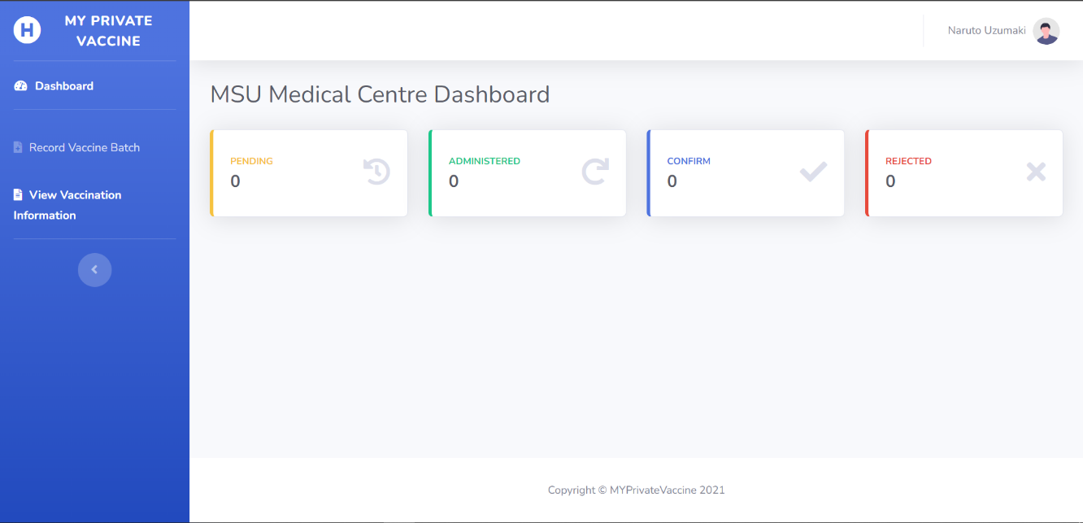

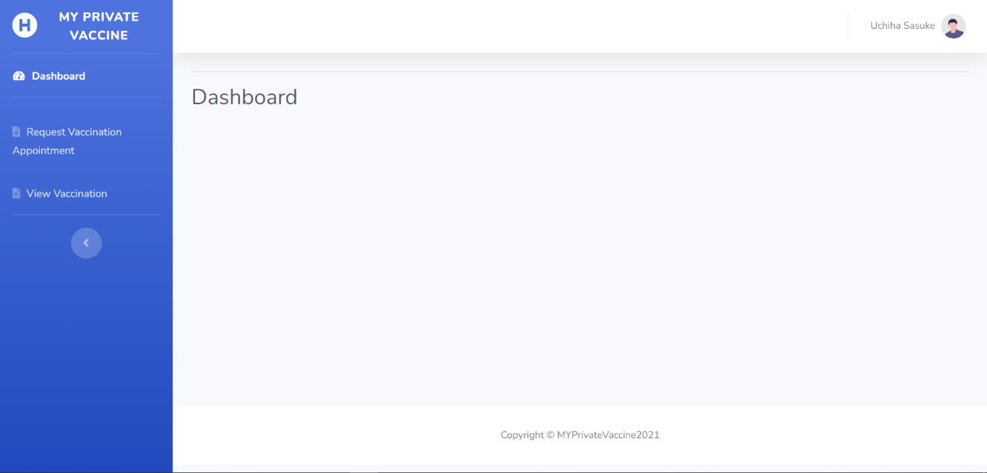

System can also be accessed through smart phone

* Tablet

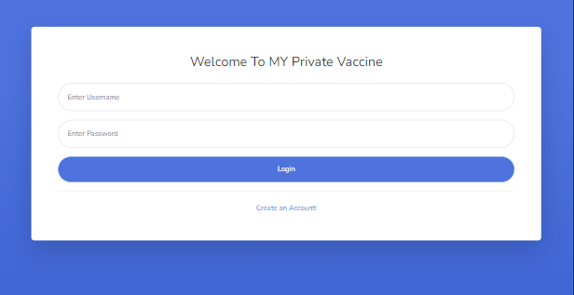

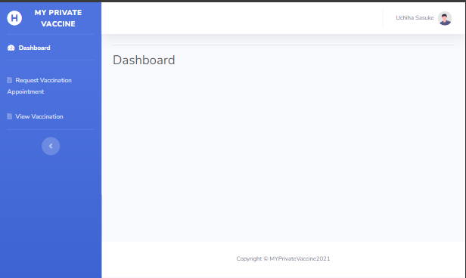

* Mobile Phone

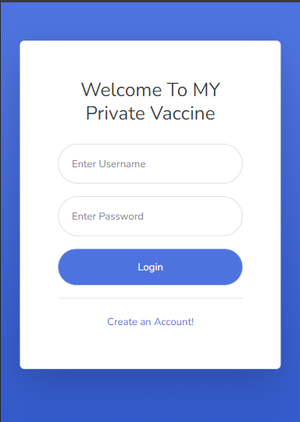

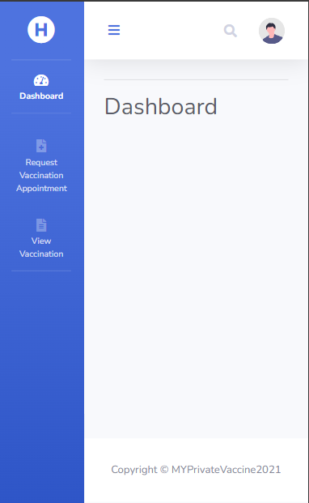

## Test Analysis Report

Four tests on the use cases produced in this initial iteration, starting with unit testing, integration testing, and system testing (functional and non-functional), show that the three use cases are qualified under the specified requirements. The absence of errors during testing and the test results indicate that the designed use case is capable of running in line with the requirements.

## Gantt Chart Update

* Before

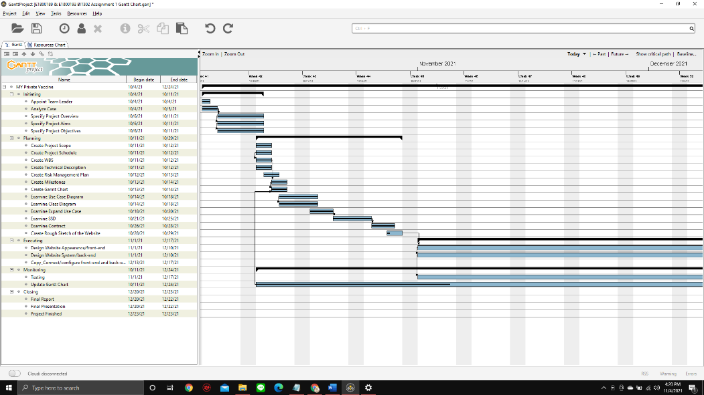

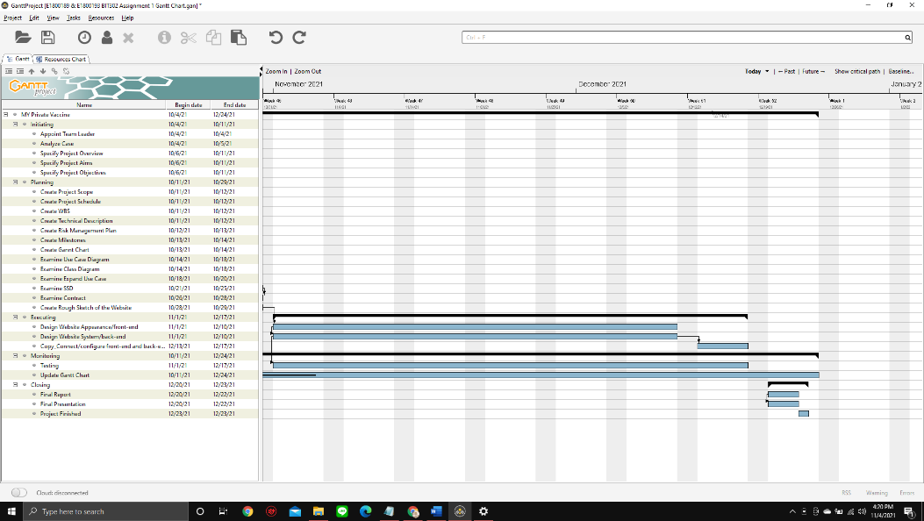

* After

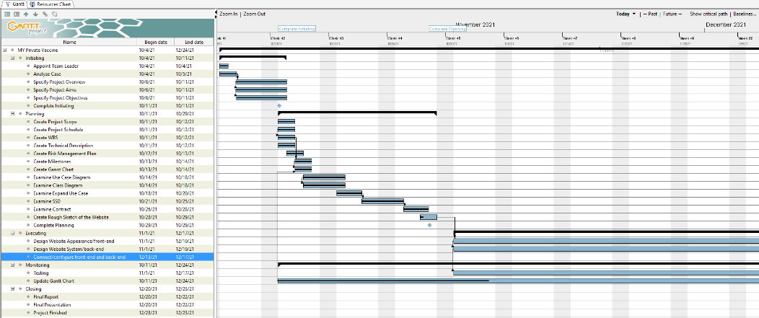

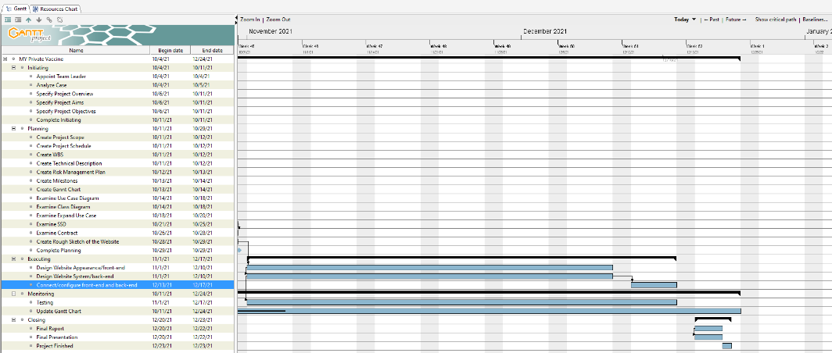

## Git Hub

Git Hub link: <https://github.com/zaraathifa/MY-Private-Vaccine.git>

* Git Hub Main Page

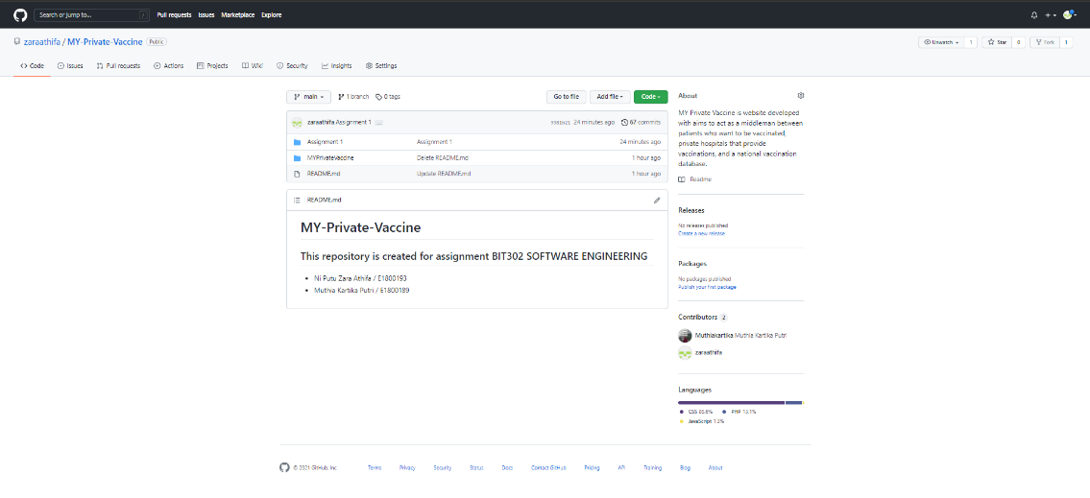

* Git Hub Commit History

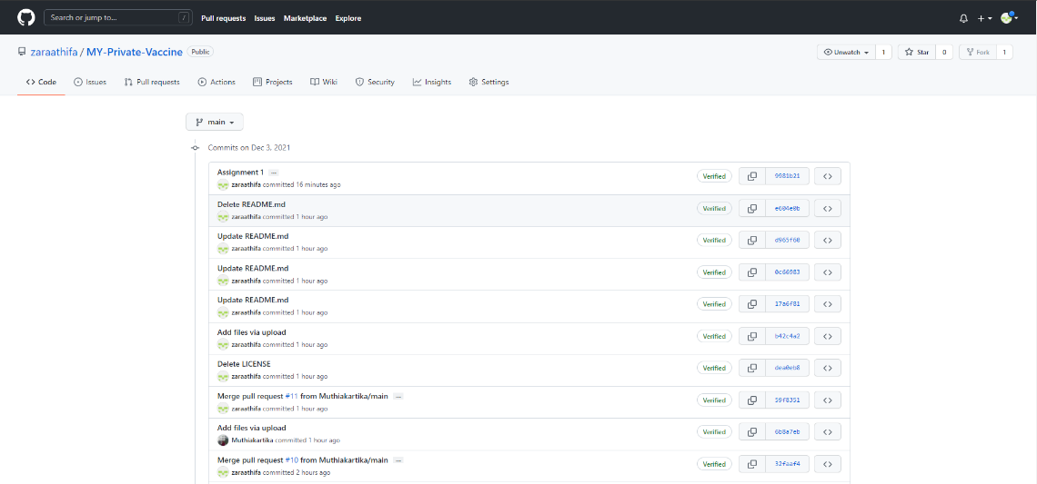

* Git Hub Contributor Insight

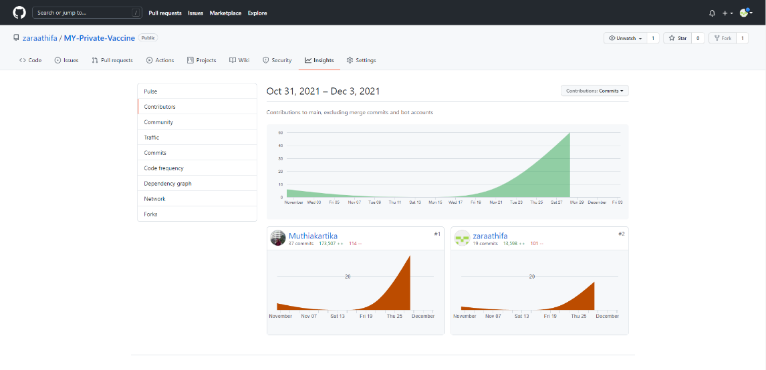

# References

Hamilton, T. (2021, October 7). *TEST OLAN: What is, How to Create (with Example).* Guru99. <https://www.guru99.com/what-everybody-ought-to-know-about-test-planing.html>

**Appendix B – Peer Evaluation (Individual)**

**Made by: Ni Putu Zara Athifa Wijana (E1800193)**

|  |  |  |  |  |  |
| --- | --- | --- | --- | --- | --- |
| **Skills** | **4 Advanced - exceeds expectations** | **3 Competent - meets expectations** | **2 Progressing - does not fully meet expectations** | **1 Beginning - does not meet expectations** | **Score** |
| Contributions & Attitude | Always cooperative. Routinely offers useful ideas. Always displays positive attitude. | Usually cooperative. Usually offers useful ideas. Generally displays positive attitude. | Sometimes cooperative. Sometimes offers useful ideas. Rarely displays positive attitude. | Seldom cooperative. Rarely offers useful ideas. Is disruptive. | **4** |
| Cooperation with Others | Did more than others.  Highly productive. Works extremely well with others. | Did own part of workload. Cooperative. Works well with others. | Could have shared more of the workload. Has difficulty. Requires structure, directions, and leadership. | Did not do any work.  Does not contribute. Does not work well with others. | **3** |
| Focus, Commitments | Tries to keep people working together. Almost always focused on the task. Is very self-directed. | Does not cause problems in the group. Focuses on the task most of the time. Can count on this person. | Sometimes focuses on the task. Not always a good team member. Must be prodded and reminded to keep on task. | Often is not a good team member. Does not focus on the task. Let others do the work. | **4** |
| Ability to Communicate | Always listens to, shares with, and supports the efforts of others. Provides effective feedback. Relays a lot of relevant information. | Usually listens to, shares with, and supports the efforts of others.  Sometimes talks too much. Provides some effective feedback. Relays some basic information that relates to the topic. | Often listens to, shares with, and supports the efforts of others. Usually does most of the talking.  Rarely listens to others.  Provides little feedback. Relays very little information that relates to the topic. | Rarely listens to, shares with, or supports the efforts of others. Is always talking and never listens to others.  Provides no feedback. Does not relay any information to teammates. | **4** |
| Accuracy -  documentation/coding etc. | Work is complete, well-organized, error-free, and done on time or early. | Work is generally complete, meets the requirements of the task, and is mostly done on time. | Work tends to be disorderly, incomplete, inaccurate, and is usually late. | Work is generally sloppy and incomplete, contains excessive errors, and is mostly late. | **3** |
|  |  |  |  | TOTAL | **18/20** |

Provide appropriate **measurables/milestones/deliverables** to support your answers for the following questions:

* 1. How effectively did your group work?
* We have never had any big problems or difficulties that have affected the continuation of this project until the time this peer was written, so I dare claim that we are working very, very effectively. We will sustain and even improve our collaboration in the future.
  1. Were the behaviors of any of your team members particularly valuable or detrimental to the team? Explain.
* This project has only two members. Muthia Kartika Putri capacity to be an optimistic and positive person is one of the qualities I like in her. And, because we are bound by deadlines and other duties, those two characteristics are really crucial to me in maintaining my sanity for the continuity of this project.
  1. What did you learn about working in a group from this project that you will carry into your next group experience (e.g. assignment 3)?
* During this group project, I learned a lot. One of them is the significance of team communication in order to avoid miscommunication. Because there are two distinct people with different opinions, ways of thinking, and personalities, communication is essential.

**Appendix B – Peer Evaluation (Individual)**

**Made by: Muthia Kartika Putri (E1800189)**

|  |  |  |  |  |  |
| --- | --- | --- | --- | --- | --- |
| **Skills** | **4 Advanced - exceeds expectations** | **3 Competent - meets expectations** | **2 Progressing - does not fully meet expectations** | **1 Beginning - does not meet expectations** | **Score** |
| Contributions & Attitude | Always cooperative. Routinely offers useful ideas. Always displays positive attitude. | Usually cooperative. Usually offers useful ideas. Generally displays positive attitude. | Sometimes cooperative. Sometimes offers useful ideas. Rarely displays positive attitude. | Seldom cooperative. Rarely offers useful ideas. Is disruptive. | **3** |
| Cooperation with Others | Did more than others.  Highly productive. Works extremely well with others. | Did own part of workload. Cooperative. Works well with others. | Could have shared more of the workload. Has difficulty. Requires structure, directions, and leadership. | Did not do any work.  Does not contribute. Does not work well with others. | **3** |
| Focus, Commitments | Tries to keep people working together. Almost always focused on the task. Is very self-directed. | Does not cause problems in the group. Focuses on the task most of the time. Can count on this person. | Sometimes focuses on the task. Not always a good team member. Must be prodded and reminded to keep on task. | Often is not a good team member. Does not focus on the task. Let others do the work. | **4** |
| Ability to Communicate | Always listens to, shares with, and supports the efforts of others. Provides effective feedback. Relays a lot of relevant information. | Usually listens to, shares with, and supports the efforts of others.  Sometimes talks too much. Provides some effective feedback. Relays some basic information that relates to the topic. | Often listens to, shares with, and supports the efforts of others. Usually does most of the talking.  Rarely listens to others.  Provides little feedback. Relays very little information that relates to the topic. | Rarely listens to, shares with, or supports the efforts of others. Is always talking and never listens to others.  Provides no feedback. Does not relay any information to teammates. | **4** |
| Accuracy -  documentation/coding etc. | Work is complete, well-organized, error-free, and done on time or early. | Work is generally complete, meets the requirements of the task, and is mostly done on time. | Work tends to be disorderly, incomplete, inaccurate, and is usually late. | Work is generally sloppy and incomplete, contains excessive errors, and is mostly late. | **4** |
|  |  |  |  | TOTAL | **18 /20** |

Provide appropriate **measurables/milestones/deliverables** to support your answers for the following questions:

1. How effectively did your group work?

* We work together very effectively. We often exchange ideas and hold meetings both offline and online so that the project runs smoothly.

1. Were the behaviors of any of your team members particularly valuable or detrimental to the team? Explain.

* The other team member, Zara Athifa who is also the leader, is doing her job well. She really cares about details and was able to correct me if something was missed. Zara Athifa is also a good listener.

1. What did you learn about working in a group from this project that you will carry into your next group experience (e.g. assignment 3)?

* The lesson I took from this project was the importance of teamwork, because it is difficult to do all the necessary work alone. Also I during this project I can hone my problem solving and time management skills